**Water Workforce: Improving Water Infrastructure and Promoting Economic Opportunity**

Joseph Kane and Adie Tomer

**Executive Summary**

As the U.S. economy continues to grow, many communities are struggling to translate this growth into more equitable and inclusive employment opportunities. Meanwhile, many of the country’s water infrastructure assets are in urgent need of repair or restoration, and the workers responsible for carrying out these efforts are in short supply.

However, these two challenges offer an enormous economic and infrastructure opportunity: water infrastructure is well positioned to offer more durable careers to a wide variety of workers. Constructing, operating, designing, and governing the country’s various water infrastructure systems demands a skilled workforce, who fill long-term positions in all types of markets nationally. Moreover, water utilities – who employ many of these workers – are found everywhere, not only providing an essential service for communities, but also acting as anchor institutions.

By analyzing occupational employment data, this report explores the water workforce in greater depth to uncover the accessible, well-paying opportunities in this space. In particular, it finds that:

**A. In 2016, nearly 1.7 million workers were directly involved in designing, constructing, operating, and governing U.S. water infrastructure, spanning a variety of industries and regions.** Water utilities represent one of the single biggest employers in the water sector, but multiple other industries and establishments, including engineering firms and construction contractors, are crucial to consider as well. Collectively, the water workforce fills 212 different occupations – from positions in the skilled trades to financial, administrative, and management positions – that are found everywhere, from big metropolitan markets to smaller rural areas.

**B. Water occupations not only tend to pay more on average compared to all occupations nationally, but they also tend to offer more equitable wages. In particular, they pay up to 50 percent more to workers at lower ends of the income scale.** Water workers earn hourly wages of $14.01 and $17.67 at the 10th and 25th percentiles, respectively, compared to the hourly wages of $9.27 and $11.60 earned by all workers at these percentiles across the country. Significantly, workers across 180 of the 212 water occupations – or more than 1.5 million workers – earn higher wages at both of these percentiles, including many positions that tend to require lower levels of educational attainment.

**C. Most water workers need less formal education to qualify for their jobs, including 53 percent having a high school diploma or less. Instead, they require more extensive on-the-job training and familiarity with a variety of tools and technologies.** While 32.5 percent of workers across all occupations nationally have a high school diploma or less, a majority of water workers fall into this category, speaking to the lower formal educational barriers to entry into these types of positions. However, 78.2 percent of water workers often need at least 1 year of related work experience, and 16 percent often need 4 years or more, highlighting the need for applied learning opportunities.

**D. Water workers tend to be older and lack gender and racial diversity in certain occupations; in 2016, nearly 85 percent of them were male and two-thirds were white, pointing to a need for younger, more diverse talent.** Some water occupations are significantly older than the national median (42.2 years old), including water treatment operators (46.4 years old). Meanwhile, women make up only a fraction of employment in some of the largest water occupations overall, including plumbers (1.4 percent). Finally, there is a particularly low share of Black and Asian workers employed in the water sector; together, they only make up 11.5 percent of the water workforce, compared to 18 percent of those employed in all occupations nationally.

In addition to these quantitative findings, the report draws off extensive qualitative information – based on dozens of conversations with utility leaders and other workforce groups – to further investigate the water workforce opportunity across the country. By doing so, the report considers several of the major hurdles that face water workers and employers looking to fill positions in this sector. It also lays out a set of actionable strategies – a new water workforce playbook – that local, state, and national leaders should use in future hiring, training, and retention efforts. Ultimately, the report reveals the sizable economic opportunity offered by water jobs, including the variety of occupations found across the country, the equitable wages paid, the lower educational barriers to entry, and the need for more diverse, young talent.

**Introduction**

It has been years since the Great Recession receded, but shared prosperity is still a challenge in many communities across the United States. High-income households are now earning up to 14 times as much as low-income households in some markets.[1] Racial disparities in employment are also widespread; from 2015 to 2016, employment rates for whites increased in 72 of the country’s 100 largest metro areas, but they increased in only 41 of these metro areas for both whites and people of color.[2] Individual neighborhoods are also experiencing deeply entrenched levels of poverty, as their residents remain disconnected from opportunity.[3] Meanwhile, smaller metro areas and rural localities are accounting for a dwindling share of national output, resulting in fewer jobs in these regions overall.[4]

Fortunately, many communities are also beginning to develop new strategies to promote more inclusive economic development.[5] Despite continued uncertainty at the national level, local leaders are accelerating new investments in technological innovation, affordable housing, and workforce development to help their residents overcome barriers to better pay and shared prosperity. In support of an increasingly diverse population,[6] these strategies are helping all types of individuals respond and adapt to the economic disruptions of today’s digital age, where an ever-changing set of skills and training are needed.[7]

Investing in infrastructure represents one of the timeliest ways for the country to support long-lasting pathways to economic opportunity for all Americans. Infrastructure-related occupations tend to earn competitive wages, but also do not require as much formal education to fill long-term jobs.[8] And the country’s water infrastructure, in particular, is well positioned to offer more durable careers to a wide variety of workers.

The economic opportunity stems from the urgent investment needs around the country’s water infrastructure assets. Municipalities, led by water utilities[9], are often at the front line of this challenge, responsible for more than 95 percent of public spending on operations and capital improvements annually.[10] With $655 billion in capital investments needed nationally over the next 20 years alone, utilities are working alongside a host of different partners to address physical infrastructure needs head-on.[11] Together, for instance, 30 of the country’s largest water utilities are estimated to spend $23 billion annually on operations and capital projects over the next decade, while contributing $524 billion to the economy.[12]

Renewing America’s water infrastructure demands a skilled and diverse workforce to construct, operate, and maintain facilities for decades to come. This responsibility falls to water utilities, other employers, workforce development partners, and state and national leaders to develop a water workforce to meet ongoing demands. This level of coordinated, purposeful action requires understanding the scope of the challenge and revisiting workforce development systems. It also needs to acknowledge how utilities are often positioned as anchor institutions in many regions, with nearly 52,000 water systems spread across the country.[13] There is a genuine opportunity to promote shared prosperity in the communities that utilities and other water leaders serve.

This report aims to identify the extent of the U.S workforce involved in overseeing water infrastructure. Through a combination of quantitative and qualitative information – including dozens of conversations with utility leaders and other workforce groups across the country – the report finds that the water workforce represents a crucial segment of the labor market.[14] To start, the report first examines some of the major hurdles that face water workers and employers looking to fill positions in this sector. It then explores the economic opportunity offered by water jobs, including the variety of occupations found across the country, the equitable wages paid, the lower educational barriers to entry, and the need for more diverse, young talent. The report outlines some of the major implications emerging from this analysis, before finally laying out a set of actionable strategies – a new water workforce playbook – that local, state, and national leaders should use in future hiring, training, and retention efforts.

**What is water infrastructure?**

Water infrastructure spans several different manmade and natural systems that supply, treat, and conserve one of the most fundamental resources to communities and the environment.[15] These systems range from traditional gray infrastructure, such as pipes, pumps, and centralized treatment plants, to green infrastructure, such as rain gardens, bioswales, and other related natural assets that tend to be more decentralized.[16] They also include individual on-site treatment systems, such as septic systems, and other related physical assets specific to individual buildings, such as plumbing.[17] In addition, rivers, lakes, ponds, wetlands, and subsurface aquifers are critical components of water infrastructure, as well as large manmade structures, such as aqueducts and levees. When this report refers to “water infrastructure,” it is referring to the country’s full suite of drinking water, wastewater, stormwater, and green infrastructure systems.

The water workforce carries out work activities that ultimately support this extensive network, which is vital to providing and protecting clean, safe, and reliable water each day. The report’s methods section describes these definitions in greater depth.

**Background**

The following sections describe the major employment opportunities – and challenges – found in the water sector. After first discussing the types of workers involved, the second section examines the primary groups focused on water workforce development. The final three sections then describe some of the prevailing difficulties that water utilities and other leaders face when trying to hire, train, and retain skilled water workers.

***Who are water workers?***

Traditionally, water utilities have taken a lead role defining and addressing the country’s water workforce needs, particularly in terms of drinking water and wastewater operations and management.[18] For example, water operators carry out a range of duties to support utility activities, from ensuring compliance with federal, state, and local water quality standards, to testing water and sewage samples, to monitoring facility conditions.[19] Likewise, mechanics, machinists, electricians, and instrument technicians rank among the most important mission-critical occupations identified in previous utility surveys and studies; these workers are essential to installing, calibrating, and overseeing a variety of equipment in utilities.[20] Several administrative, financial, and management occupations help support utility operations too, including customer service representatives and human resources specialists.

However, water utilities are just one of many employers looking for workers to construct, operate, design, and govern the country’s water infrastructure assets.[21]

The water sector captures a vast array of industries – from engineering and design firms to construction companies and contractors – and each rely on a different suite of occupations and workers.[22] After all, the country’s water infrastructure not only requires maintenance at individual treatment plants and other utility locations, but also depends on carrying out repairs in homes, businesses, and other public and private facilities – and relies on skilled managers and administrators to support all this activity. Similarly, water workers do not exclusively focus on gray infrastructure facilities, such as pipes and pumps. They also manage green infrastructure facilities, such as rain gardens and bioswales, which utilities and other local employers are using to better conserve environmental resources and more consistently handle stormwater runoff; as a result, a widening set of careers related to green infrastructure design, installation, and maintenance are emerging in many regions.[23]

The report’s methods section describes the specific industries and occupations that employ water workers.

***Who is responsible for hiring, training, and retaining water workers?***

In short, water workers span multiple industries across the country, and utilities are not alone in hiring, training, and retaining these workers to oversee all the various infrastructure projects and facilities found across the sector. Rather, a wide assortment of employers, community partners, and national- and state-level actors each have roles to play in water workforce development.

To provide drinking water, treat wastewater, manage stormwater, and balance other programmatic responsibilities, **utilities** depend on a skilled workforce. Although utilities can vary markedly in the scale of their operations and workforce demands – depending on the facilities they oversee and customers they serve – they still assume a lead role onboarding and ultimately preparing workers to navigate long-term water careers. For instance, their human resources staff frequently manages recruitment and retention efforts, while their managers shape plans, budgets, and programs to emphasize particular training needs.[24] Indeed, utilities continue to rank workforce development as one of their top priorities, where they remain focused on identifying younger talent, onboarding workers more quickly, creating more flexible training platforms, and holding onto more skilled workers.[25]

**Other water-related employers**, including engineering firms, contractors, and related businesses, are also actively on the lookout for workers to carry out specific water projects and activities. As part of the procurement process, many of these employers respond to utility requests for project support, including design and construction, but they are also engaged in other miscellaneous services, ranging from vehicle maintenance to meter reading.[26] In addition, through project labor agreements with utilities and other public agencies, contracted firms may often be required to hire workers locally, amounting to 50 percent or more of the contracted workforce in some markets.[27] These employers, of course, can vary in their size and focus, providing services well beyond the purview of utilities and lead to specific hiring needs; for example, local plumbing companies may cater more to individual households or install equipment in particular buildings.

Utilities and other water-related employers benefit from a wide range of **community partners** that educate, train, and assist workers interested in water careers. For instance, local community colleges, technical schools, and educational institutions provide courses and instruction in the skilled trades, offer certification and apprenticeship programs, and connect students with various training opportunities. Similarly, economic development organizations (EDOs) and Workforce Development Boards (WDBs) are among the multiple regional partners that help oversee and collaborate on workforce development programs, by guiding financial resources, providing technical support, and forming strategic plans in support of training efforts.[28] Unions and labor groups not only provide worker protections – during the hiring process and wage negotiations, for instance – but also offer training resources and assistance.[29] Finally, a number of community-based organizations and non-profit groups offer job readiness programs, transition services, and other channels of support to workers.[30]

In addition to all the aforementioned groups, several **national- and state-level actors** are involved in water workforce development. Federally, the U.S. Environmental Protection Agency (EPA) is perhaps the most important agency when it comes to regulating utility activities and guiding workforce needs – via the Clean Water Act and Safe Drinking Water Act – while providing funding and technical assistance for training efforts, too.[31] Furthermore, the U.S. Departments of Labor (DOL), Education (ED), Veterans Affairs (VA), and Agriculture (USDA) monitor skill needs and employment trends, oversee labor standards, support apprenticeship programs, and provide targeted programmatic support for certain individuals and utilities.[32] Likewise, several industry associations are pioneering new research and collaborations to connect water workers with employment opportunities.[33] Meanwhile, a host of other national- and state-level organizations – including workforce groups, environmental coalitions, and state boards of education – are assessing existing training efforts and setting new strategic priorities.[34]

***Recognizing barriers to hiring, training, and retaining water workers***

Even with an extensive array of job types and supporting actors, there are distinct challenges facing the water sector. While the demand for water workers remains high among utilities and other employers, they struggle to attract and hold onto skilled talent; equipping workers with needed skills and credentials is not always easy; and even those workers who are eligible and interested in water work cannot always navigate an inflexible, time-consuming hiring process or progress their careers. Across the entire water sector, three categorical barriers face its workforce:

*Water workers are aging and lack diversity, while employers struggle to retain workers*

First and foremost, the water sector is experiencing a challenge to attract and hold onto skilled workers, particularly younger and more diverse workers. Several related studies point to a general shift away from the skilled trades and vocational education among students, which is compounded by the many existing water workers nearing or eligible for retirement.[35] A lack of public visibility, combined with declines in career and technical education (CTE), has reduced interest and experience among prospective workers who could fill water-related positions.[36] The physically demanding nature of work in some water jobs can also be a turnoff for prospective workers and existing staff.[37] And it’s not just entry-level job candidates either—there is a shortage of mid-career professionals to take on supervisory roles as well.[38]

The timing could not be worse for water utilities. Many utility employees first started working for utilities during a “hiring boom” in the 1970s when the federal government launched new water investments and implemented new regulations across the country.[39] For instance, in an independent survey of water and wastewater professionals, respondents were on average 56 years old, and 38 percent were 60 years or older; meanwhile, just 3 percent of respondents were 30 years old or younger.[40] This “silver tide” of retirements is drastically cutting into the pool of skilled, qualified workers in many utilities and resulting in staffing vacancies of up to 50 percent in some cases.[41]

At the same time, the lack of diverse workers is apparent across many water utilities. Even though utilities are often located in disadvantaged communities where a diverse range of residents and workers live, they do not always reflect the demographics of the population they serve.[42] Industry surveys found more than 72 percent of workers in water utilities are white.[43] And while some utilities boast higher shares of black, Asian, and Hispanic workers, there can still be notable gaps in particular occupations.[44] Moreover, women are consistently under-represented across many water utilities, particularly in the skilled trades and in management positions, where they make up just 6 percent of water utility CEOs.[45]

Finally, the water sector also experiences struggles to retain workers. For example, while water utilities offer numerous employee benefits and tend to pay attractive wages, salaries can be modest compared to competitor industries, including private-sector peers in energy or construction.[46] In regions with a high cost of living and productive economies, the prospect to relocate to a lower-cost region or another employer can also be a frequent consideration for workers with in-demand skills.[47] Meanwhile, smaller utilities can frequently lose workers looking to transition to bigger utilities that may offer more growth opportunities.[48] Across the entire economy, many younger workers are also showing an interest in jumping from one employer to another on a more frequent basis than in the past; this new normal is a reality that utilities and other water employers are likely to face in future retention efforts.[49]

*Difficulties defining needed skills and creating portable, versatile credentials*

Identifying a new generation of workers will be key for the water sector in years to come. However, that task is difficult given the wide range of curricula and ever-changing training requirements depending on the specific employer.

Although levels of formal education required can be low for many positions in the water sector, workers still require an extensive range of knowledge: in chemistry theory, hydraulics principles, water and ventilation systems, basic plumbing, math, and statistics, among other disciplines. Many water workers must understand operating manuals and plumbing specifications, operate precision instruments, and communicate technical information.[50] The sector is also becoming increasingly dependent on Supervisory Control and Data Acquisition (SCADA) systems and other related computer systems, which may decrease the number of operators needed to run water plants and require an evolving set of qualifications for future job candidates.[51]

Perhaps more importantly, the pathways to developing such knowledge and skills are unclear, especially from region to region. Not all workers gain the needed education or experience to develop competency in the mix of hard and soft skills essential to their occupation. The changing nature of work in the sector, including new types of field work, new design guidelines, and increased automation, only add to the breadth of necessary skills.[52] These varying skill requirements may also fall outside the typical job readiness training efforts and assistance programs offered by a range of community partners, including WDBs, which help connect prospective workers with potential employment opportunities.[53]

Similar to other skilled trades, many water workers start as apprentices, where a combination on-the-job training and classroom instruction help equip them with the practical and theoretical tenets of their occupation. After completing their apprenticeship, the worker becomes a journey level tradesman and then transitions into a role with more limited supervision.[54] Crucially, though, while plumbers, pipefitters, and other technicians follow the apprenticeship path, not all water workers follow this track. As one example, those interested in becoming water operators must hold at least a high school diploma, obtain a combination of training and experience at a utility, and pass an operator exam in order to become licensed or certified.[55] The education and licensing requirements for these positions can vary widely across different states as well, and not all utilities or regions have flexible training programs in place to equip workers with needed experience.[56] As a result, prospective job candidates may fail to pass certification exams or qualify for positions.

*Challenges hiring and developing talent*

As more workers retire or leave the water workforce, it can be a struggle to find qualified replacements. Even when students and other prospective workers demonstrate an interest in water careers, pursue needed education, and gain relevant experience, there can still be challenges hiring them and providing long-term growth opportunities.

Collaboration among local employers and supporting institutions is notoriously difficult. Ideally, the creation of more proactive, visible recruitment strategies would draw from efforts across multiple employers, training providers, and other local leaders. However, competition and hoarding of information among different employers looking for workers with similar skillsets can stop collaboration before it starts.[57] Instead, recruitment efforts often occur in isolation and some workers may have limited awareness about what specific water positions are available.

Moreover, depending on the particular region, many prospective workers may lack job readiness, may remain out-of-work due to a criminal past, or may present a non-traditional background, which employers may not have the time, resources, or programmatic flexibility to handle. The creation of new internship programs, directed toward high school students and other young workers, are helping to address these gaps, but many job candidates still lack the minimum experience needed to fill certain positions, and there is often a lack of predictable, long-term funding and staffing for these efforts.[58]

Given the highly localized nature of water operations, capital planning needs, and labor demands, there are no one-size-fits-all strategies to address these recruitment challenges, which often spill over into the hiring process. Employers can vary widely in their hiring practices, including how long it takes, how they rate individual candidates, and how much control they actually have over adjusting prevailing hiring standards. During the procurement process, for instance, utilities can rely on local hiring preferences to support minority and women business enterprises (M/WBEs), but this requires creative thinking, diligent monitoring, and continued experimentation.[59] In addition, rigid job classifications developed by human resources decades ago – and negotiated with unions – may make it difficult to customize or adjust the training required for certain types of jobs.[60] Likewise, some utilities may need to partner with broader city departments to receive necessary approvals for new job classifications or training programs. Finally, existing human resources staff may not always have the capacity, flexibility, or experience themselves to relate to (or address) the concerns of more diverse, non-traditional job candidates.

Finally, while utilities and other water employers want to help prospective workers not simply find a “job” but secure a “career pathway,” they face several programmatic constraints to foster professional growth. In terms of training, employers need to do a better job shifting knowledge down and moving workers up; hiring new workers only represents the start of a process where employers need to expand and replicate needed skillsets at all levels of the career ladder.[61] Doing so requires a more intentional budgeting process where workers are prioritized alongside potential infrastructure improvements. At the same time, developing more robust competency models, clearer succession planning efforts, and providing opportunities for continued learning and retraining are essential but often not present.[62]

**Methodology**

Many previous reports covering the water workforce have only focused on those workers directly employed in the country’s drinking water, wastewater, and stormwater utilities. However, as noted above, this approach can overlook the many additional workers employed across other establishments that provide goods and services essential to the country’s water infrastructure, ranging from engineering firms to construction contractors. To measure the full economic extent and impact of the U.S. water workforce – and the jobs they fill – this analysis relies on the following definition:

***Water workers are directly involved in the construction, operation, design, and governance of water infrastructure systems nationally, including drinking water, wastewater, stormwater, and green infrastructure. These workers fill positions that span the public and private sector and involve oversight, maintenance, and financial and administrative support, including involvement in managing several closely-related physical assets, such as pipes and septic systems.***

Based on a thorough review of academic literature, industry reports, government studies, utility surveys, and other workforce documents, the analysis builds off this definition to identify a consistent list of *industries* that carry out water-related activities nationally.[63] Spanning the public and private sector, a total of **eight different “water” industries** are included, which are involved in: (1) providing drinking water, treating wastewater; and managing stormwater; (2) overseeing water, sewer line, and related structures construction; (3) overseeing dredging and flood control project construction; (4) installing and servicing plumbing equipment; (5) trenching, excavating, and preparing sites for septic systems; (6) cleaning storm basins and sewers, in addition to remediating and revegetating contaminated sites to improve water quality; (7) providing environmental consulting services in support of regulatory compliance; and (8) performing other closely-related local government activities.[64]

The analysis then looks at the variety of positions – or *occupations* – that workers fill across these industries to get a more precise sense of the duties and tasks they carry out in support of the country’s water infrastructure.[65] In total, **212 unique “water” occupations** are identified whose employment is often linked to specific water infrastructure assets and other relevant activities.[66] For example, water treatment operators, hydrologists, meter readers, and septic tank servicers and sewer pipe cleaners are among the vast number of occupations included in this analysis. Similarly, a variety of engineering- and construction-related occupations, such as civil engineers, pile-drive operators, and pipelayers, use specialized knowledge and tools to draft plans, handle equipment, and install structures. In addition, several administrative, financial, and management positions, including secretaries, office clerks, and architectural managers, are found to provide essential support and oversight for these activities.

By investigating these water occupations in greater depth, the analysis estimates employment totals for the water workforce as a whole. Specifically, employment totals are based on the concentration of the 212 water occupations in the eight water industries noted above.[67] For example, almost all water treatment operators nationally tend to concentrate in these eight industries – and thus account for high levels of employment in the water workforce overall. However, bill and account collectorswork in an enormous range of national industries and represent a small share of total water employment. National levels of occupational employment serve as a foundation for other metrics, including estimated water employment in metro areas.[68] The analysis also creates separate estimates for water utility employment across the country.[69]

Once determining specific levels of occupational employment, the analysis explores trends in wages, education, training, and skills for the water workforce. It additionally considers several demographic characteristics, such as age, gender, and race by occupation. Overall, this approach parallels many of the same methods used in previous Brookings Institution “infrastructure jobs” analyses, which focused on identifying and measuring the range of long-term positions that oversee the country’s transportation, energy, water, telecommunications, logistics, and other related infrastructure facilities.[70]

For more information on the report’s methodology, see Appendix A.

**Key Terms[71]**

**Water Jobs:** Employment opportunities based on the total number of workers in occupations and industries involved in overseeing the country’s water infrastructure, including drinking water, wastewater, stormwater facilities, and other related assets.

**Occupations:** The activities that employees regularly carry out for pay, which are grouped into distinct categories on the basis of similar job duties as outlined in the 2010 Standard Occupation Classification (SOC) system. In total, there are more than 800 detailed occupations found across all industries. “Water occupations,” in particular, are often concentrated in activities and perform duties central to water infrastructure design, construction, operation, and governance.

**Industries:** Groups of establishments that provide similar goods or services, as determined by the 2012 North American Industry Classification System (NAICS). Private and government-owned establishments are included, while agricultural establishments and private households are excluded. “Water industries,” in particular, provide services closely linked to water infrastructure.

**Employment:** The total number of full-time and part-time workers paid a wage or salary, excluding household and self-employed workers, as defined in the Bureau of Labor Statistics (BLS) Occupational Employment Statistics (OES) survey.

**Wages:** Based on straight-time, gross pay over a standard work period, as defined in the OES survey. These include tips, production bonuses, cost-of-living allowances, and over-the-road pay based on mileage. However, overtime pay, back pay, and holiday bonuses are among the types of compensation excluded. Wages include mean hourly and annual pay, but also percentile wages (10th, 25th, 50th, 75th, and 90th). The latter are based on the percentage of workers who earn wages below a certain value. For instance, if $9.00 represents the 10th percentile wage for a given occupation, this means that 10 percent of workers employed in the occupation earn less than this amount.

**Findings**

**A. In 2016, nearly 1.7 million workers were directly involved in designing, constructing, operating, and governing U.S. water infrastructure, spanning a variety of industries and regions.**

From water utilities, to specialty trade contractors, to heavy and civil engineering construction, there are hundreds of thousands of workers that carry out specialized activities crucial to the long-term operation and maintenance of the country’s drinking water, wastewater, and stormwater facilities. Traditionally, water utilities are seen as the primary – or only – employer involved in overseeing the country’s water infrastructure assets. However, a broader look at the water workforce nationally reveals that utilities employ 298,000 workers, or about 17.7 percent of the total water workforce.Other water-related employers, led by plumbing contractors and construction firms, employ nearly 1.4 million workers.

**Figure 1: Utility Share of Total Water Workforce Employment, 2016**

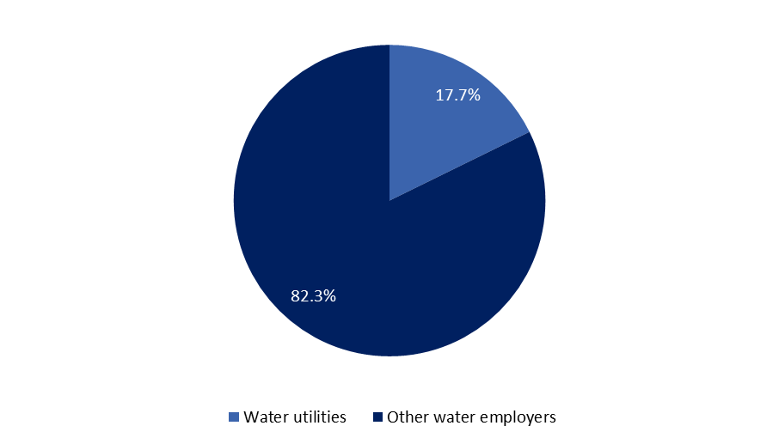

*Source: Brookings analysis of BLS Occupational Employment Statistics*

Water utilities represent one of the leading employers for water workers, but they are just one part of a complex economic sector filled by a variety of firms and establishments looking for skilled talent. However, since most utilities are publicly owned and operated and have formal responsibilities to serve the public, they are especially crucial to overseeing the country’s essential water infrastructure facilities, such as water treatment plants, which can also provide clearer pathways to economic opportunity, as will be explored later in Box C.

Collectively, the water workforce fills 212 different occupations and carries out an enormous range of activities, whether installing and repairing equipment or analyzing and overseeing operations. For example, water treatment operators, electricians, and plumbers, pipefitters, and steamfitters rank among the 15 largest water occupations overall, employing 1.1 million workers by themselves, or almost two-thirds of all water workers nationally. Many of the same occupations are also common within water utilities, as Table 1 illustrates below. In addition to positions in the skilled trades, there are tens of thousands of other workers involved in administration, finance, and management, including 116,000 office clerks, secretaries, and general and operations managers across the entire water workforce.

**Table 1: 15 Largest Occupations, Across the Entire Water Workforce and Across Utilities, 2016**



*Source: Brookings analysis of BLS Occupational Employment Statistics*

Perhaps most importantly, water workers are not isolated to only a few areas across the country, but are employed everywhere, speaking to their enormous geographic reach. For instance, they consistently represent 1 to 2 percent of total employment in most of the country’s metro areas. As Figure 2 shows, the country’s 100 largest metro areas are job hubs for the water sector much like they are hubs for total U.S. employment. These 100 places are home to almost 1.4 million water workers, or 82 percent of the national total. Just 10 metro areas are responsible for 25 percent of the national total, led by New York, Los Angeles, and Houston. While not shown, non-metro areas and rural localities also depend on many of these workers, boasting a total water employment of nearly 307,000 workers.

**Figure 2: Water Workers in the 100 Largest Metro Areas, By Total Employment and Share of Employment, 2016**

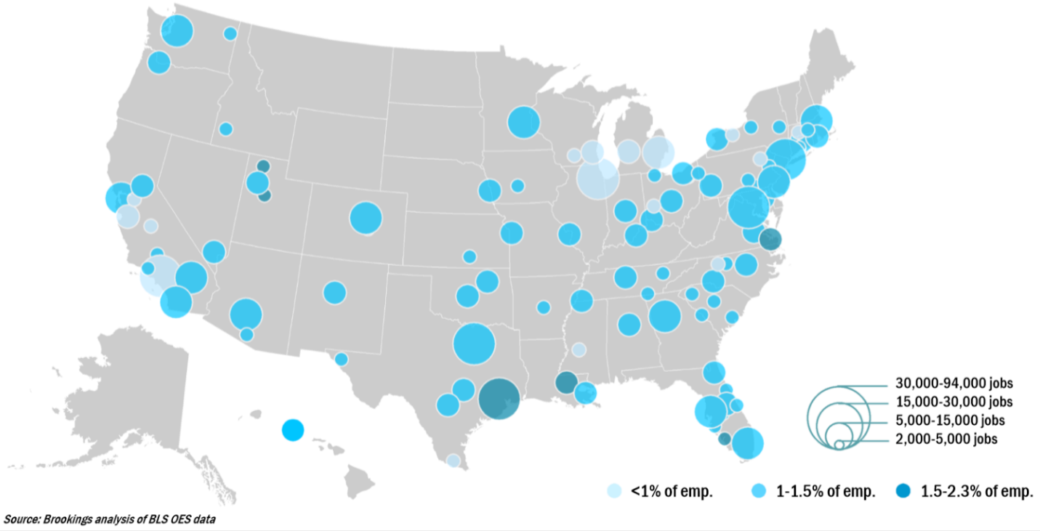

The presence of water utilities in most places means their employment is also dispersed across all corners of the country. Similar to the water workforce as a whole, water utility workers are found in larger metro areas and smaller rural localities alike. The largest metro areas, however, tend to employ many of these workers overall; 109,000 workers, or almost 37 percent of their total national employment, are located in 25 metro areas alone, from Washington and Philadelphia to Seattle and San Francisco.

**B. Water occupations not only tend to pay more on average compared to all occupations nationally, but they also tend to offer more equitable wages. In particular, they pay up to 50 percent more to workers at lower ends of the income scale.**

On average, water workers earn higher wages ($25.22 an hour) compared to all workers nationally ($23.86 an hour). These not only include higher-paying occupations overall, such as lawyers, hydrologists, and general and operations managers, but also span a variety of other technical and financial positions, such as civil engineers, environmental scientists, and budget analysts.

Crucially, these wage premiums do not end there; water workers at lower ends of the income spectrum, especially at the 10th and 25th percentile, earn more competitive wages compared to all workers nationally. Specifically, water workers earn hourly wages of $14.01 and $17.67 at the 10th and 25th percentiles, respectively, compared to the hourly wages of $9.27 and $11.60 earned by all workers at these percentiles across the country.

**Figure 3: U.S. Hourly Wage Comparison: Water Occupations vs. All Occupations, 2016**

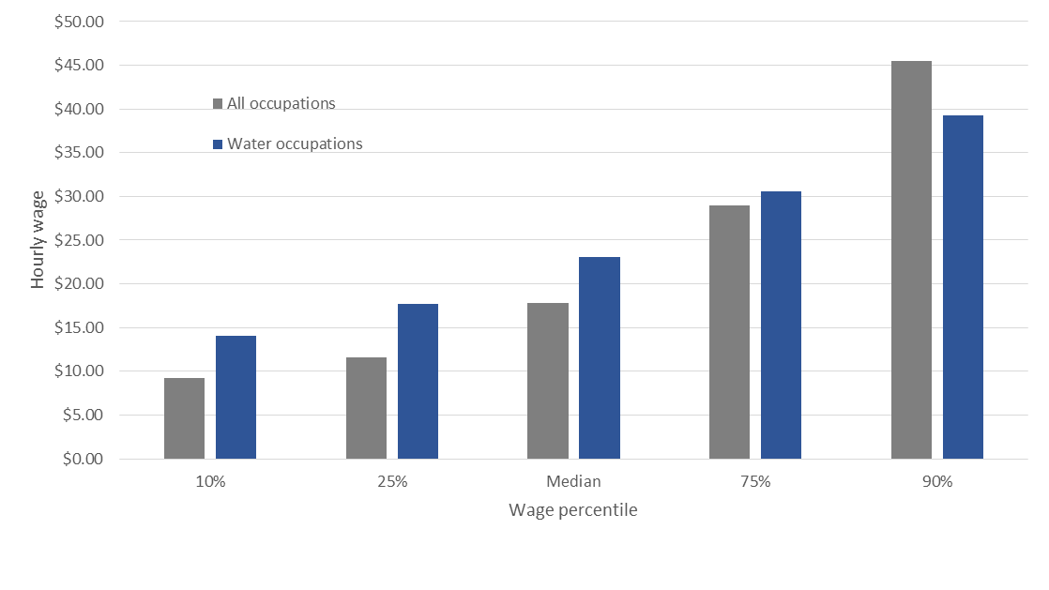

*Source: Brookings analysis of BLS Occupational Employment Statistics*

In total, workers across 180 of the 212 water occupations – or more than 1.5 million workers – earn higher wages at both the 10th and 25th percentiles. Moreover, workers in nine of the ten largest water occupations – and 23 of the 25 largest water occupations – earn more at these percentiles. The only exceptions are: office clerks and laborers. As Table 2 shows, the fact that these equitable wages often appear in occupations where workers have lower levels of educational attainment further underscores the opportunity evident in the water workforce.

**Table 2: Selected Water Occupations with Higher Wages at the 10th and 25th Percentile,**

**By Educational Attainment, 2016**



*Source: Brookings analysis of BLS Occupational Employment Statistics and Employment Projections data*

Furthermore, these equitable water wages reach all types of areas nationally. For example, Table 3 provides a snapshot of how water wages compare to the wages that all workers receive at the 10th and 25th percentile. From Minneapolis and Milwaukee to Kansas City and Phoenix, water workers can earn as much as $9 more per hour compared to all workers at these lower income levels. While several other factors, such as cost-of-living, need to be taken into account when comparing these differences across different regions, water workers are clearly gaining access to a variety of well-paying employment opportunities across the country.[72]

**Table 3: Water Wage Differences in Selected Metro Areas, 2016**



*Source: Brookings analysis of BLS Occupational Employment Statistics*

**C. Most water workers need less formal education to qualify for their jobs, including 53 percent having a high school diploma or less. Instead, they require more extensive on-the-job training and familiarity with a variety of tools and technologies.**

While 32.5 percent of workers across all occupations nationally have a high school diploma or less, a majority of water workers fall into this category, speaking to the lower formal educational barriers to entry into these types of positions, as shown in Figure 4. In fact, workers across 111 different water occupations tended to only possess a high school diploma or less, including carpenters, welders, and septic tank servicers and sewer pipe cleaners.[73] Crucially, most of these workers still tended to earn competitive wages regardless of their levels of educational attainment, especially at the 10th and 25th percentile, as discussed in the previous finding.

**Figure 4: Educational Attainment for Workers in Water Occupations vs. All Occupations, 2016**

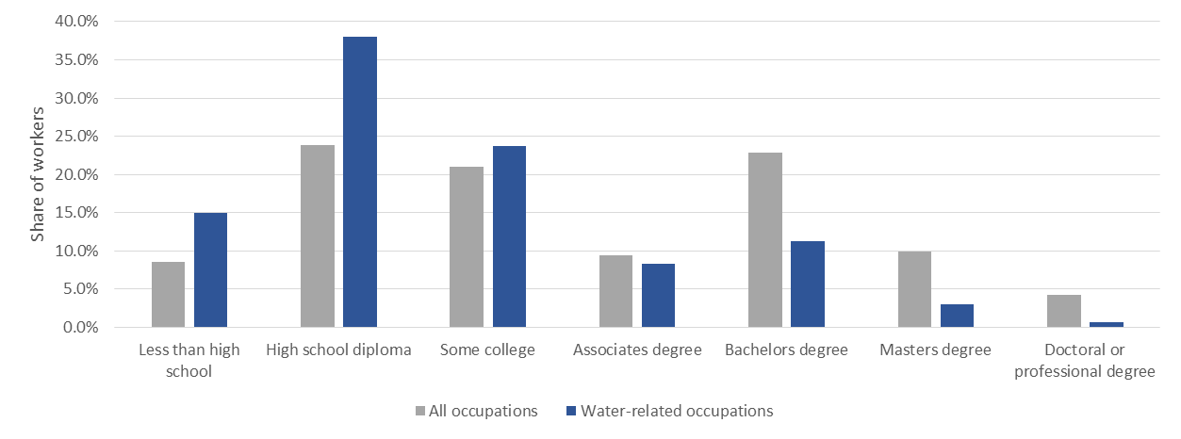

*Source: Brookings analysis of BLS Occupational Employment Statistics and Employment Projections data*

However, as also illustrated in Figure 4, it is important to note that there are still many highly educated and specialized water workers as well. While only 14.9 percent of water workers hold a bachelor’s degree or higher, landscape architects, environmental engineers, and computer systems managers often have higher educational credentials – and boast higher wages overall.

While formal education requirements are lower relative to many other occupational groups, nearly all water workers tend to require some related work experience and on-the-job training, which highlight the need for applied learning opportunities. For example, 78.2 percent of water workers need at least 1 year of related work experience, including 16.0 percent who need 4 years or more (Figure 5). Water treatment operators, plumbers, and HVAC technicians are among the many large occupations that require 2 to 4 years of related work experience. Unlike workers across all occupations nationally – 86.5 percent of who typically need little to no related work experience – water workers develop and depend on specialized skillsets over time.[74]

**Figure 5: Related Work Experience Often Required in Water Occupations,**

**By Share of Employment, 2016**

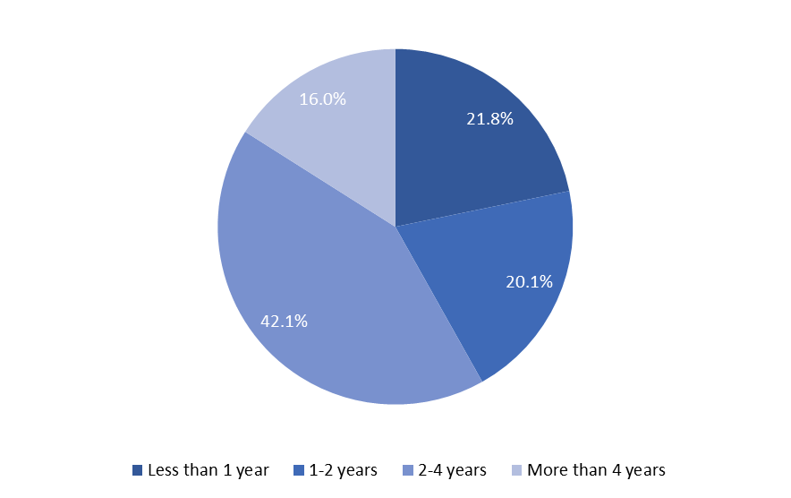

*Source: Brookings analysis of BLS Occupational Employment Statistics and O*NET data.*

Not only do water workers require extensive experience, they usually need some level of on-the-job training to qualify for their positions. Although they tend to not require as much on-the-job training as they do related work experience –44.5 percent of water workers often need at least 1 year or more of on-the-job training – it is still a common requirement among the largest occupations overall. For instance, water treatment operators, electricians, and sheet metal workers frequently need 2 to 4 years of on-the-job training. This is also significantly higher than what workers across all occupations nationally typically need; only 5.6 percent need more than 1 year of on-the-job training.[75]

**Figure 6: Levels of On-The-Job Training Often Required in Water Occupations,**

**By Share of Employment, 2016**

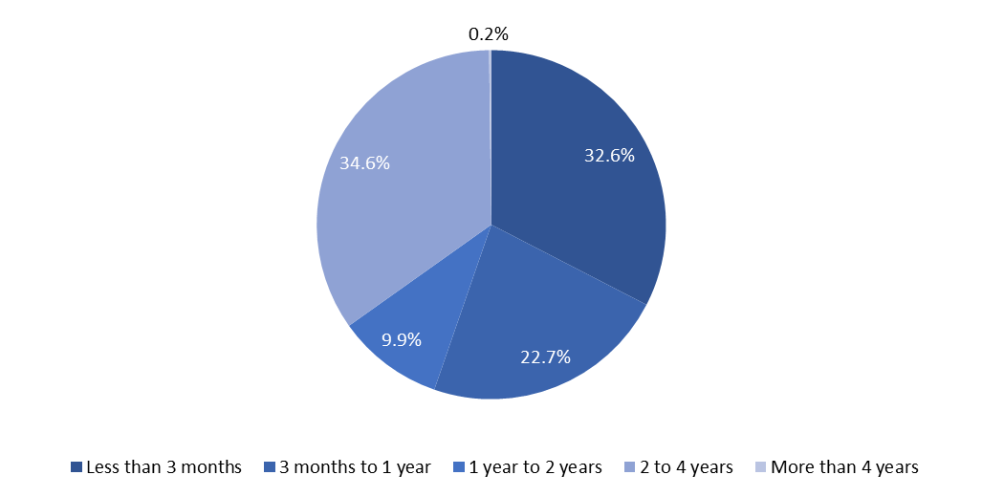

*Source: Brookings analysis of BLS Occupational Employment Statistics and O*NET data.*

Water workers embody the definition of skilled trades. On average, water workers use 63 different tools and technologies each, compared to the 6 tools and technologies typically used by workers in all occupations nationally.[76] While tools include specific physical commodities like screwdrivers, ladders, and claw hammers, technologies include specific software packages that deal with word processing, database management, and computer aided design (CAD). Figures 7 and 8 below list the 15 most common tools and technologies used in water occupations, respectively. Interestingly, the intense use of computers and software packages is indicative of their growing digitalization overall.[77]

**Figure 7: 15 Most Common Tools Used in Water Occupations, By Share of Employment, 2016**

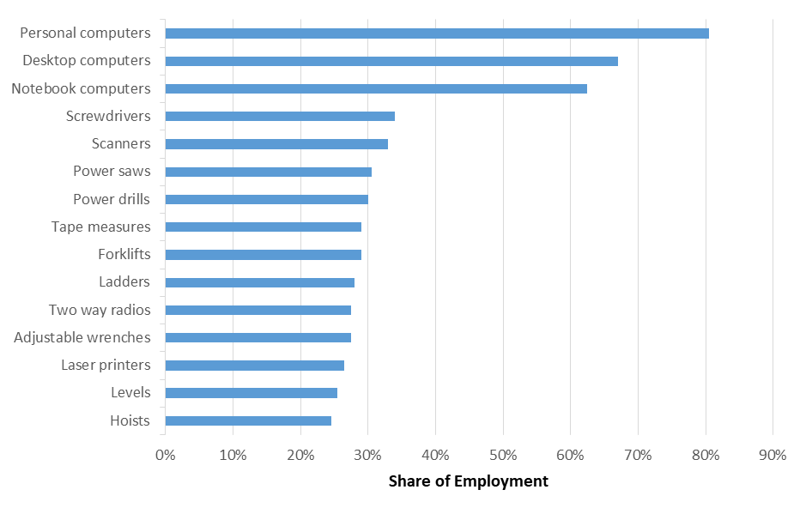

*Source: Brookings analysis of BLS Occupational Employment Statistics and O*NET data.*

**Figure 8: 15 Most Common Technologies Used in Water Occupations, By Share of Employment, 2016**

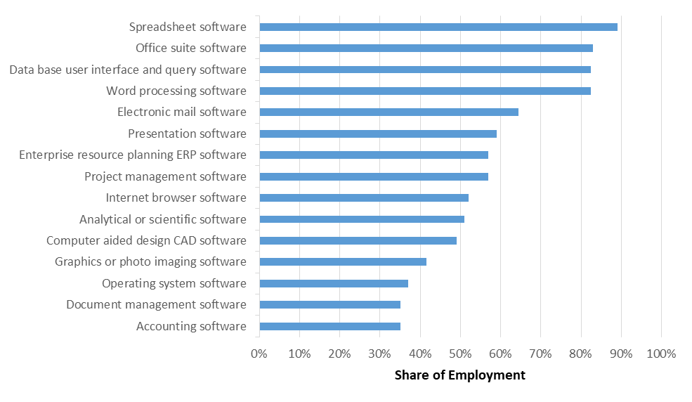

*Source: Brookings analysis of BLS Occupational Employment Statistics and O*NET data.*

**Box A: Water occupations share similar expertise with other infrastructure occupations**

Work in the water industry certainly requires a wide range of hard and soft skills; whether employed as carpenters and plumbers or as managers and budget analysts, water workers are often familiar with customer service, public safety, and administration, to name only a few content areas. Significantly, water workers possess higher levels of knowledge in many of the same content areas that other *infrastructure workers* do, who are employed in transportation, energy, and related industries.[78] By examining data in greater depth from O*NET—an information resource sponsored by the U.S. Department of Labor’s Employment and Training Administration—it becomes easy to see how similar the water workforce and broader infrastructure workforce can be when it comes to their specific knowledge and skills development. And this similarity has significant and positive implications for shared workforce development ambitions.

Through a series of worker questionnaires, the O*NET database ranks the extent to which occupations require knowledge across 33 different categories on a scale from 0 (minimum) to 7 (maximum). Relative to all occupations nationally, infrastructure occupations score above average in 11 of these knowledge categories.[79] Previous Brookings analyses exploring infrastructure occupations have shown how many of these workers – from railroad conductors to ship captains to power line installers – are involved in the long-term operation and maintenance of the country’s roads, waterways, and power plants. Not surprisingly, as illustrated in Table 4 below, they require especially high levels of transportation, mechanical, and public safety knowledge, among numerous other content areas.[80]

**Table 4: Knowledge Categories where Infrastructure Occupations**

**Score Higher than the National Average**



*Source: Brookings analysis of O*NET data.*

Critically, the water workforce tends to boast relatively high knowledge scores in the same categories as other infrastructure occupations. For instance, environmental engineers, civil engineering technicians, and electrical and electronics repairers tend to have extensive knowledge in many of these content areas, including mechanical, construction, and design knowledge. Such *knowledge correlations* create a promising situation where water workers possess advanced skills that will often translate well across multiple infrastructure-related industries. Considering the 14.5 million jobs across the entire infrastructure supersector, this presents a national opportunity to create a shared workforce development platform covering common knowledge requirements, leaving only specialized trainings within efforts specified occupations. The potential scale economies—combined with the durable pathways to opportunity infrastructure jobs offer—make this a critical area for workforce development innovation.

**D. Water workers tend to be older and lack gender and racial diversity in certain occupations; in 2016, nearly 85 percent of them were male and two-thirds were white, pointing to a need for younger, more diverse talent.**

As many previous studies have shown, thousands of water workers are aging and expected to retire from their positions in years to come, leading to a huge gap to fill for utilities and other water employers. With a median age of 42.8 years, water workers are slightly older than the national median (42.2) across all occupations. Yet some water occupations are significantly older, including architectural and engineering managers (48.9 years old), machinists (48.3), and water treatment operators (46.4). Depending on the specific utility, the age of individual employees must often be viewed in terms of their retirement eligibility as well, which may frequently be the case for these particular occupations.

However, the challenge is not simply limited to a workforce with a higher median age, which Figure 9 illustrates in greater detail. First, slightly more water workers (45.2 percent) are in the prime of their careers – considered 35 to 54 years old – when compared to all workers nationally (42.2 percent). Put another way, the water workforce has a relatively full pipeline of middle-aged workers. Second, and perhaps more importantly, there is a lack of younger talent in these jobs. Just 10.2 percent of water workers are under the age of 24, compared to 12.5 percent of all workers nationally.

**Figure 9: Age Range of Workers in Water Occupations vs. All Occupations, 2016**

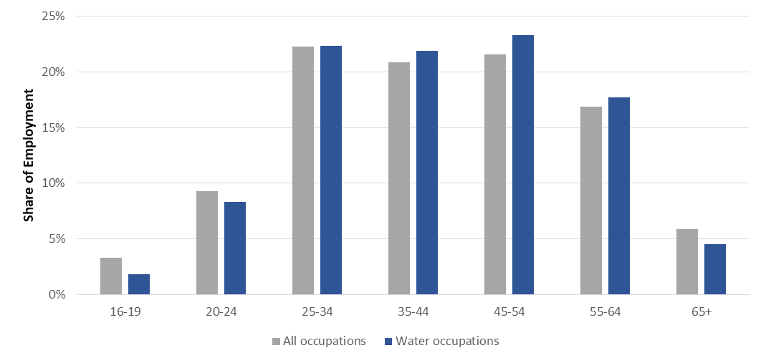

*Source: Brookings analysis of BLS Occupational Employment Statistics and CPS data.*

**Box B: Measuring future employment changes in the water workforce**

The infrastructure workforce is aging across the country, and almost 3 million workers will need to be replaced over the next decade due to retirements and other employment shifts.[81] In many ways, the water workforce reflects these broader trends, given its slightly older demographics. However, as estimated by the BLS Employment Projections program, there are several nuances to consider in when looking at future employment changes in the water sector: (1) many water workers are not simply going to retire, but are project to transfer out of the sector; (2) the water workforce is projected to grow faster compared to national averages; and (3) these separations and levels of growth will lead to many openings in the water sector overall.

Before discussing each of these findings, it is important to note that BLS no longer tracks “replacement needs” – the number of workers who will need to be replaced over the next decade – due to statistical limitations and other accuracy concerns.[82] Instead, BLS measures “occupational separations” to estimate an annual average of workers who are projected to permanently leave their jobs due to labor force exits (including retirements) and occupational transfers (including career changes).[83] In addition to projecting total employment growth, then, BLS looks at occupational separations as a way to measure employment shifts over time; and in many cases, even as new openings emerge as a result of future job growth, there will be far more openings as a result of workers leaving their current jobs.

From 2016 to 2026, about 10.6 percent of water workers – on average each year – are projected to either permanently leave (i.e. retire) or transfer out of their current jobs.[84] This is slightly below the national average across all occupations (10.9 percent) over the same span. In other words, while many water workers may be eligible for retirement and are simply going to exit the labor market, many others are searching for other jobs in the water sector or beyond it. For example, it is not surprising that laborers, security guards, and receptionists are among the sizable, less specialized occupations in the water sector who are more likely to leave their current jobs, with separation rates above 13.0 percent each. At the same time, though, there are some specialized occupations like septic tank servicers and sewer pipe cleaners, who are also projected to leave their current jobs more frequently (12.3 percent), signaling a potential struggles to hold onto these workers in years to come.

In addition, from 2016 to 2026, water occupations are projected to see faster overall employment growth (9.9 percent) compared to all occupations nationally (7.4 percent). While many utilities and other water employers remain understandably focused on hiring and holding onto workers – in the face of upcoming retirements – it is significant not to lose sight of the growth potential across the water sector as well. Figure 10 shows some of the water occupations projected to grow faster than all occupations nationally, including several technical positions like software developers and information security analysts alongside many positions in the skilled trades like pipelayers and plumbers.

**Figure 10: Selected Water Occupations Projected to See Faster Employment Growth, 2016 to 2026**

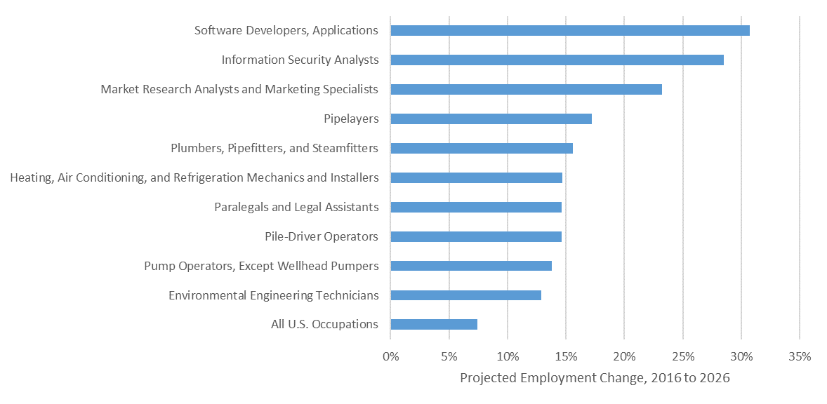

*Source: Brookings analysis of BLS Employment Projections data.*

Together, the combination of separations and future growth in the water sector is projected to lead to about 220,000 occupational openings – on average each year – from 2016 to 2026. Almost 38 percent of these projected openings – 82,500 – are concentrated in three occupations alone: plumbers, construction laborers, and operating engineers. An additional 9,200 openings are projected on average each year for water treatment operators, and many other occupations – such as electricians, carpenters, and general operations managers – are also projected to see thousands of openings each year. In short, many of the biggest water occupations are projected to have thousands of open positions over the next decade in need of skilled talent.

While the accuracy of employment projections can be imperfect, this much is clear: the water workforce is expected to continue playing a sizable role in the labor market for years to come. And the sector’s long-standing fixation on retirements does not fully capture the vast array of concerns likely to hit water workers and employers alike, including a continual ebb and flow of labor entering and leaving different positions. Similar to the U.S. economy as a whole, there are also likely to be uncertainties surrounding new technologies and automation – including the potential phasing out of some jobs and the potential creation of new jobs requiring new skills.[85] Continued monitoring of these trends is crucial to ensure the water workforce remains ready to take on new tasks and fill positions of greatest need.

Water workers are predominantly male as well, particularly among positions in the skilled trades. Although women make up 46.8 percent of workers across all occupations nationally, they only account for 14.9 percent of the water workforce. While women make up a majority of water workers in certain administrative positions – including 95 percent of secretaries – they only account for a fraction of employment in some of the largest water occupations overall, including plumbers (1.4 percent), water treatment operators (5.2 percent), and pipelayers (7.5 percent). Table 5 lists a few of the major water occupations that have relatively high and low shares of female workers.

**Table 5: Selected Occupations with High and Low Shares of Female Workers, 2016**



*Source: Brookings analysis of BLS Occupational Employment Statistics and CPS data.*

Finally, while the racial composition of the water workforce as a whole tends to generally parallel larger national trends, there is still a notable lack of diversity in certain occupations.. Indeed, even though the water workforce is focused on meeting the water infrastructure needs of many different communities across the country – and has the potential to pull from an increasingly diverse working-age population – the worker demographics do not always reflect this diversity.

For example, nearly two-thirds of the water workforce is white, similar to the ratio found across all occupations nationally (65.3 percent). However, there is a particularly low share of Black and Asian workers employed in the water sector relative to national averages across all occupations, which Figure 11 demonstrates. Together, they only make up 11.5 percent of the water workforce, compared to 18 percent of those employed in all occupations nationally. And while the Hispanic share of the water workforce (21.8 percent) actually exceeds the national average across all occupations (16.7 percent), this is primarily due to their concentration in construction jobs, as Table 6 illustrates. Along with Black workers, in particular, they tend to be underrepresented in higher-level, higher-paying occupations involved in engineering or management.

**Figure 11: Racial Diversity in Water Occupations vs. All Occupations, 2016**

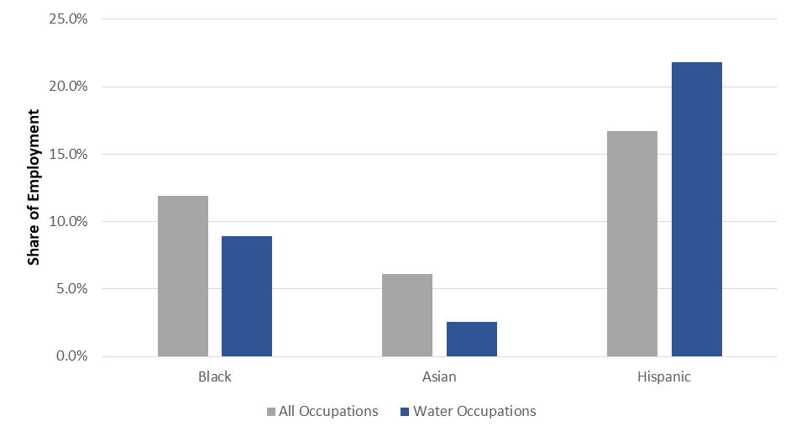

*Source: Brookings analysis of BLS Occupational Employment Statistics and CPS data.*

**Table 6: Selected Water Occupations, By Race, 2016**



*Source: Brookings analysis of BLS Occupational Employment Statistics and CPS data.*

In this way, while many water occupations pay more equitable wages and offer more accessible points of entry for all types of workers, especially in the skilled trades, there are still persistent gaps in Black, Hispanic, and Asian workers filling some of these positions. This is especially true when looking at how many water jobs are found in the country’s largest metro areas, where the working-population tends to be much more diverse –but is often enduring high levels of poverty and unemployment.[86] From Detroit and St. Louis to Jacksonville and Orlando, for instance, thousands of water jobs are present, yet many residents, representing a variety of demographic and economic backgrounds, remain on the sidelines. While some individual water utilities and other water employers may have more diverse staff, the water workforce as a whole is still lacking in this regard nationally. However, viewing these trends more closely at a sub-regional scale offers additional insights into how the water workforce offers enormous economic potential in some of the country’s most disadvantaged neighborhoods.

**Box C: Water Utilities as Economic Anchors**

Water utilities represent significant employers for water workers at both a national and metro level. In particular, they control some of the most critical public infrastructure assets in need of long-term operation and maintenance, and in many ways represent anchor institutions for their communities. The sub-regional analysis here aims to delve deeper into that role by exploring where utilities are located and how their establishments relate – geographically and otherwise – to the communities they serve.

Using a spatial dataset based on EPA's Facility Registry Service (FRS), this analysis looks at more than 12,847 publicly-owned water treatment plants nationally, with a particular focus on their location and the characteristics of the neighboring population served.[87] The water treatment plants are organized by zip code[88], which are then linked to Census tracts[89] to investigate several relevant variables, including demographics, educational attainment, unemployment, and poverty rates. These data are based on 5-year estimates from the American Community Survey (ACS).

In total, the plants analyzed are found across 32,659 unique Census tracts, serving a total population of nearly 146 million people. Given the enormous geographic extent and reach of these plants, the demographic characteristics of the population they serve often closely mirror those of the U.S. as a whole. However, there are three distinguishing characteristics worth noting: water treatment plants tend to be located in neighborhoods with (1) lower levels of educational attainment, (2) higher unemployment rates, and (3) higher levels of poverty, speaking to their importance as economic anchors to many disadvantaged workers and residents.

For example, in tracts with water treatment plants, 43.6 percent of workers have a high school diploma or less, compared to 32.5 percent of all workers nationally. In addition, unemployment rates typically exceed 5 percent, compared to the 4.5 percent unemployment rates seen nationally in 2016. Finally, 15 percent of residents in these same tracts live below poverty, slightly more than the 14 percent poverty rate seen nationally in the same year. Collectively, water treatment plants are located in tracts where: 42.5 million workers have a high school diploma or less, 5.6 million workers are unemployed, and 21.2 million residents live below the national poverty rate.

Of course, there is wide variation in these demographic and economic characteristics depending on the particular region – and tract – observed.

As just one example, consider the case of Camden, New Jersey. For instance, among those living near one of the biggest water treatment plants in Camden, NJ, 69.3 percent of workers have a high school diploma or less and unemployment stands at almost 10 percent. The poverty rate stands at 57.5 percent. Furthermore, nearly half of all residents – 47.4 percent – are black and remain traditionally underrepresented in the water workforce.

**Figure 12: Share of Camden Workers with a High School Diploma or Less, 2016**

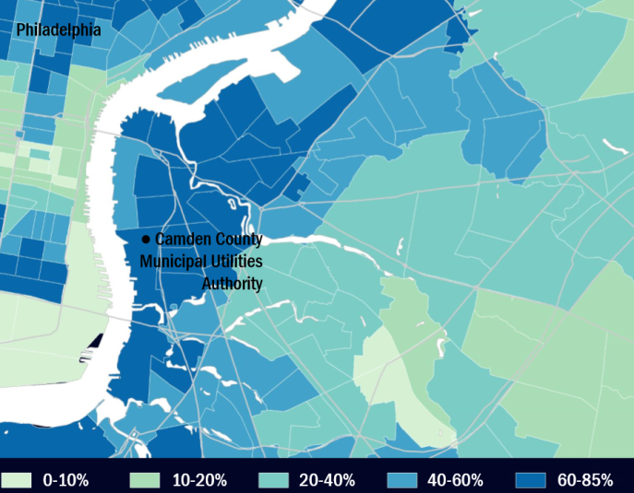

*Source: Brookings analysis of EPA FRS and Census ACS data.*

**Figure 13: Unemployment Rates in Camden, 2016**

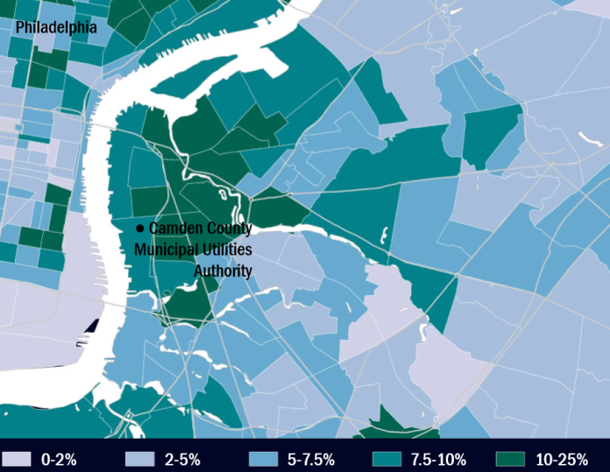

*Source: Brookings analysis of EPA FRS and Census ACS data.*

**Figure 14: Poverty Rates in Camden, 2016**

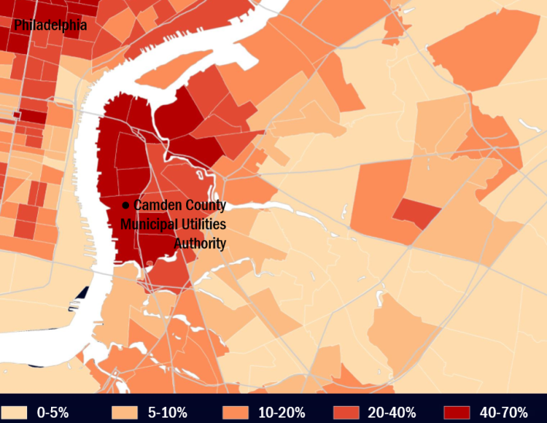

*Source: Brookings analysis of EPA FRS and Census ACS data.*

While Camden only provides a snapshot of this issue, it demonstrates how water utilities – and the public assets they oversee – can potentially play a key economic role in the communities they serve. Obviously, the hiring needs and capacities of each utility vary from region to region – and from facility to facility – but many utilities are already pioneering new workforce strategies across the country. While doing so, they are forging new collaborations and training efforts to not only improve their operations, but also to connect more workers with economic opportunity. This analysis shows that utilities are strategically located in many places where the benefits could spell economic gains in their backyard.

**Implications**

At a time when many workers remain disconnected from economic opportunity and lack the skills, training, or awareness of where to turn, the water sector offers a variety of pathways to more inclusive employment outcomes. Water jobs tend to pay more than the average American job, especially at lower ends of the income scale. They also require significantly less formal education, but help workers develop a wide range of technical skills. And with 1.7 million total jobs and geographic diffusion, water jobs exist in every corner of the country.

However, while the water sector offers clear opportunity for so many prospective workers, there are still several gaps to address in order to hire, train, and retain a skilled and diverse water workforce in years to come.

First, as the background section described, the water workforce needs greater public visibility, especially when it comes to its ability to support more inclusive economic outcomes. The water workforce captures a broad range of accessible employment opportunities, from those involved in the skilled trades to a variety of technical, financial, and administrative positions. But despite the higher pay and lower formal educational barriers to entry, students and other prospective workers are still not gaining the needed skillsets, not looking to pursue careers in the water space, or may simply fail to get into entry-level positions due to a lack of experience and other factors.[90]

Without greater visibility, the water sector may continue to struggle with a lack of diversity too. The water workforce is aging and faces a growing employment gap to fill, especially among younger workers. Although the water sector provides durable employment opportunities for many male workers concentrated in construction and other related activities – who were hit particularly hard during the recession – there are clear areas where more women could be exploring water careers.[91] The underrepresentation among Black and Asian workers overall – and Hispanic workers in certain occupations – spells a particular need to connect with a wider pool of prospective workers, particularly those living in areas with higher levels of unemployment and poverty.

Third, identifying and hiring skilled workers remains a struggle for many utilities and other water employers. As mentioned earlier in the report, a number of different factors play a role here, from inflexible civil service hiring requirements to difficulties collaborating with other regional partners. Yet, the report has pointed to the importance of looking for talent in places that may not traditionally have attracted as much attention. For instance, since water workers rely on broad-based infrastructure knowledge, including familiarity with construction, engineering, and design principles, there are likely many workers with complementary and transferable skills employed in transportation, energy, and other related industries. The lack of portable and versatile credentials across the infrastructure sector represents a barrier for workers and employers alike. At the same time, the fact that the physical operations of many water utilities are located in areas with lower levels of educational attainment, higher unemployment rates, and higher levels of poverty illustrates the vast economic opportunity facing communities nationwide; while utilities may not have hiring needs in all these areas, they stand as important anchor institutions that could serve as outlets for additional training and collaboration.

Fourth, the need for more extensive work experience and on-the-job training in the water sector highlights the skilled tasks that the water workforce carries out every day. However, as water workers embark on long-term careers that depend on lifelong learning, the importance of supporting applied learning opportunities in this space is crucial, and that support – financially, programmatically, or otherwise – may not always be in place. In addition to emphasizing technical and vocational education, for instance, supporting internships, apprenticeships, and other training programs is crucial. And while equipping younger students with needed skills and experience matters, so does training (and retraining) workers further along in their careers. Prospective job candidates often need to acquire knowledge quickly, but gaining experience is not always easy; training programs are often geared toward younger workers, licensing requirements can vary widely across states, and workers with non-traditional backgrounds may not even know where to start.

Likewise, workers already employed throughout the water sector must continue to strengthen their competencies and adapt their skills to a rapidly evolving workplace, increasingly filled with new demands and technologies. The need to retain and grow talent within the water sector remains a pressing concern for utilities and other employers who depend on a steady stream of operators, engineers, analysts, and managers, among numerous other workers. Projected replacement needs, moreover, are expected to grow in coming years, including high levels of turnover among some of the most specialized water occupations. Whether investing in continued training, defining new competency models, or empowering workers in other ways, many employers are striving to develop and hold onto skilled water workers. Doing so, though, often hinges on progressive leadership in these organizations, an ability to balance long-term budgets with staffing needs, and an appetite for experimentation – which can be rare in a sector known more for its cautious, conservative approach to managing change.[92]

Finally, there must be an acknowledgement of the varying scale and capacity of different communities – and utilities in particular – to tackle these challenges and ultimately expand the water workforce opportunity. For instance, personnel costs comprise more than 47 percent of total operations and maintenance expenses each year for utilities, and growing pension obligations are increasing the weight of these financial needs.[93] Financial and programmatic capacity issues can be a particular concern among smaller utilities; after all, more than half of all water and wastewater utilities nationally have only one or two employees, and about 85 percent have three or fewer.[94] Some smaller systems even share operators or depend on volunteers to reduce costs.[95] Training and salaries are necessary for utilities to meet their obligation to the public to provide safe, reliable, and affordable service,[96] but they are often limited in their financial means to do so.

**Recommendations**

Together, water utilities, other water employers, community partners, and federal and state leaders have a long list of “to-do’s” to further elevate and expand the country’s water workforce opportunity. Ultimately, given the nuances in many of the barriers to hire, train, and retain skilled water workers, locally-driven actions are crucial to develop new strategies and target new investments. But the scale of the issue demands broader regional collaborations and national support to build additional financial, technical, and programmatic capacity. Not all places, or utilities, are equally equipped to accelerate their workforce development efforts, even if they have an appetite to test out new ideas.

In many ways, addressing the country’s water workforce needs represents an aspirational moment, a time when faster implementation is essential to drive new solutions. And to accomplish that, there needs to be a **new water workforce playbook** to accelerate thinking and action. No single strategy – or individual actor – is going to lead these efforts, and some issues will be costlier and take longer to address. Rather than continually reflecting on what needs to be done, having a consistent and discrete list of action items can help utilities, other water employers, community partners, and national and start leaders begin to prioritize and launch solutions.

The following three sections discuss specific steps that three different groups can take in the years to come. The first section covers utility- and employer-driven actions, developed and executed internally. The second section considers several regional actions, driven in concert between employers and other community partners. Finally, several national- and state-level actions are proposed, designed to build additional local financial and technical capacity. As a starting point, these strategies can serve as a guide for communities and leaders to customize depending on their specific needs and priorities.

Many of these recommendations emerged during site visits and interviews carried out in advance of this report’s release. Over the course of several months, Brookings researchers traveled to three different regions – California’s Bay Area; Louisville, Kentucky; and Camden, New Jersey – to better highlight best practices and other on-the-ground experiences in the water infrastructure space. Brookings researchers also held an expert roundtable in Washington, DC, to investigate cross-cutting national-level issues focused on water workforce development. In addition to exploring the role of water utilities to support greater economic opportunity, these events aimed to bring together several different voices to the table – including educational institutions, workforce development groups, and researchers, among other stakeholders – to reflect on a broad scope of issues related to the recruitment, training, and retention of water workers.

**1. Utilities and other water employers need to empower staff, adjust existing procedures, and pilot new efforts in support of the water workforce**

✔ Hire and train dedicated human resources staff to meet with younger students, connect with more diverse prospective workers, and explore alternative recruitment strategies

✔ Create a new branding strategy to more effectively market the utility or organization to younger students and a broader pool of prospective workers

✔ Account for workforce needs as part of the budget and capital planning process, while creating more detailed and consistent labor metrics

✔ Update or create new job categories to provide greater flexibility for potential applicants

✔ Develop competency models – or customize existing models – to promote continued learning and skills development among staff

✔ Design and launch new bridge programs, including “water bootcamps,” to provide ways for younger workers and other non-traditional workers to explore water careers and gain needed experience

✔ Implement a formalized mentorship program to provide interns and younger workers a clear point of contact and better monitor their career progression

Locally-driven actions are crucial to help workers achieve the needed skills and identify the available pathways to securing greater economic opportunity through the water sector. And these actions naturally start at the source: utilities and other water employers looking to hire, train, and retain a skilled, diverse workforce. Water utilities, in particular, not only need to focus on recruiting and retaining workers for themselves, but they should be a standard bearer for the entire water sector. Through a variety of internal programmatic changes, they can heighten awareness of the water workforce opportunity and further prioritize action around faster hiring, more flexible training, and more predictable retention.

To do so, utilities and other water employers need progressive leadership willing to explore and test out new ideas.Engaging in continuous knowledge sharing and experimentation, and piloting new efforts, depends on active leaders. And it’s not just about leadership at the top, but individual staff stepping up and taking action – and giving these staff the flexibility and time to pioneer new ways of thinking and administer change.

For instance, expanding public outreach and awareness, particularly among a more diverse set of prospective workers, depends on having skilled staff in place to pioneer new strategies. Utilities and other water employers should **hire and train dedicated human resources staff to meet with younger students, connect with more diverse prospective workers, and explore alternative recruitment strategies**.Relying on word-of-mouth and hiring “friends and family” have often defined past entry points for workers into the water field, which does not come close to addressing the more pressing needs of the water sector today.[97] There is a need to more directly market and reach out to the community, and having a liaison in place to coordinate with other community partners. For instance, several utilities are already doing this, including the East Bay Municipal Utility District, which has an equal employment opportunity coordinator seeking to further diversify the agency’s workforce.[98]

Expanding recruitment efforts also hinges on the development of a more proactive and intuitive message on water careers. To help connect with younger students and a broader range of prospective workers, utilities and other water employers should **create a new branding strategy** to more effectively market their organization – and the variety of work opportunities in the water space. For example, the Baltimore Public Works Department recently re-branded some of their training efforts under a new title and logo, “Y-H2O”, to appeal more directly and intuitively with students and other prospective workers.[99] In particular, connecting earlier and often with students can help create a stronger pipeline for years to come, especially in elementary and middle school. Demonstration projects in the community, including new rain gardens and other visible green infrastructure upgrades, can also create opportunities for the water sector to highlight their leadership in the community and introduce their work, not just as service providers but as environmental stewards.

Programmatically, conducting more extensive public outreach and hiring more workers, though, require a long-term commitment to balancing infrastructure and facility budgets (typically the biggest priority for utilities) with workforce demands. Succession planning is crucial in this respect, but so is a more detailed accounting and measurement of labor demands, including where hiring needs in the organization are most pressing and what skills are most needed. In turn, utilities and other water employers should **account for workforce needs as part of the budget and capital planning process, while creating more detailed and consistent labor metrics.** This is not only true when projecting labor needs at individual facilities as part of the capital planning process, but it is also needed when looking at the demographic profile of existing workers and planning for the rise of digital skills and other emerging technologies in the workplace. The San Francisco Public Utilities Commission (SFPUC) is one of many utilities, for instance, that has aimed to customize their budget planning process not simply in light of the physical infrastructure demands, but in terms of the pressing staffing needs as well.[100]

At the same time, getting more skilled workers on board quickly depends on adjusting internal human resource processes and other prevailing administrative procedures, which may be holding back the creation of newer hiring and training platforms. Utilities and other water employers should **update or create new job categories to provide greater flexibility for potential applicants**. Among public sector employers, in particular, strict civil service hiring requirements – often developed decades ago – make it hard to create “exceptions” to hire candidates who may lack a very narrowly-defined set of credentials and experience. Adjusting these anachronistic practices is easier said than done, but should be addressed with a greater sense of urgency, as some public agencies continue to consider on an ongoing basis.[101]

Once workers are actually in the system, employers must continue investing in their skills development and valuing their role in the organization. One way to do so is for utilities and other water employers to **develop competency models – or customize existing models – to promote continued learning and skills development among staff**. Specifically defining and measuring the types of knowledge, skills, and abilities needed among water workers can better target future training efforts; competency models help organizations do so in light of individual worker needs and career trajectories, in addition to the actual positions of greatest need. Some utilities are beginning to test out new models in this way, although the time commitment to do so must remain a consideration.[102] Likewise, utilities like Atlanta’s Department of Watershed Management are continuing to focus on new technologies in the workplace and the need to consider “smart utility” actions in the future.[103]

Of course, training workers, especially those just starting out their water careers, depends on having well-defined, accessible opportunities to develop skills and gain needed experience. And while existing internship and apprenticeship programs help in this respect, the demand to fill these programs often outstrips the number of openings – and not all candidates may qualify. For that reason, utilities and other water employers should **design and launch new bridge programs, including “water bootcamps,” to provide ways for younger workers and other non-traditional workers to explore water careers and gain needed experience.** It is critical that prospective workers, including students and other non-traditional candidates like veterans, have flexible opportunities to become familiar with the work and the types of opportunities available in the water sector.

From California to Kentucky to New Jersey, a variety of innovative training programs are emerging to equip workers with needed skills and experience. In the Bay Area, for instance, utilities have worked closely with local schools and neighborhoods to provide engaged learning opportunities, including green infrastructure demonstration projects.[104] Likewise, in Louisville, some employers, including those in the energy sector, have already organized or are looking to hold weekly boot camps to quickly introduce prospective workers to careers in the trades.[105] Through a Green Jobs Summer Ambassadors Program, Camden has sought to create a quick, immersive experience for high school students aimed at introducing them to green and water-related careers, which has already helped create and maintain 50 green infrastructure projects across the city.[106]

The creation of these programs, though, should only represent a start to expanding needed skillsets and exposing workers to water careers. Some of the most innovative training programs (including those listed above) are still nascent, and continued monitoring of program performance is essential to gauge the outcomes of past interns and better meet the needs of new interns. Utilities and other water employers should **implement a formalized mentorship program to provide interns and younger workers a clear point of contact and better monitor their career progression.** The Louisville Metropolitan Sewer District (MSD), for instance, is currently testing out this approach in its internship programs.[107] Supporting mentorships would also help empower existing workers in their current roles, who often represent the best teachers and models to demonstrate the skilled nature of their everyday work.

**2. A broad range of employers and community partners need to hold consistent dialogues, pool resources, and develop platforms focused on water workers**

✔ Identify a common regional “point person” – or organization – to schedule and steward consistent meetings among a broad range of community partners

✔ Hold an annual water summit/meet-and-greet where prospective workers, employers, and community partners can connect with one another regionally

✔ Out of these dialogues, develop a comprehensive water workforce plan, highlighting regional training needs and avenues for additional collaboration

✔ Develop a more predictable, durable channel of funding to support these efforts, driven by public fees and private-sector support

✔ Strengthen local hiring preferences in support of more minority and women business enterprises

✔ Create a new web platform to connect water workers and employers, serving as a simple, consolidated site for regional job postings

✔ Launch a new regional “academy” – designed and run by employers and community partners – in support of more portable infrastructure education, training, and credentials

Many localities and utilities are already driving new workforce solutions, but there needs to be continued dialogue and shared learning via stronger community partnerships. In other words, to reach more prospective workers, all types of community partners and employers – not just utilities – need to sit at the same table. Educational institutions, WDBs, unions, and a range of other organizations all have a role to play, and it is critical for communities to keep stretching the tent to capture more partners and act more collaboratively. Without coordinated leadership and action, it will be difficult to achieve scale across a sector that can be highly fragmented and localized in its operations.

Of course, it is also crucial to emphasize that different regions bring different needs (and capacities) to the table. While larger metropolitan areas may have dozens of groups with the interest and ability to coordinate on new workforce development activities, smaller or more rural communities may only have a couple organizations engaged in these efforts. No two places are the same – even those located in the same region or state – and ultimately the roles and responsibilities must be tailored to the unique concerns of a given community. However, there are some common practices that could translate well across different places, which serve as the basis for this section.

Indeed, just as utilities and other water employers need to have specific staff members driving change internally, **there needs to be a common regional “point person” – or organization – to schedule and steward consistent meetings among a broad range of community partners**. Obviously, the individual players involved and needs identified will vary from region to region, but having a consistent person or group to mobilize action is essential, even if it means picking a specific date and location to meet. Whether formal or informal, arranging time for new dialogues and planning should be a first step to unite different community partners around a common set of priorities. And that is much easier to do when there is a common point of contact. For example, the Camden Collaborative Initiative (CCI) has served as a regional body and platform to define priorities, encourage discussion, and test out new ideas, with a focus on improving environmental and economic outcomes; and CCI’s success has depended on specific non-profit partners to schedule and plan meetings.[108]

Collaborating on a daily, weekly, or even a monthly basis can be challenging, and not all community partners may have the time, resources, or willingness to engage that frequently. Sometimes, even having just one opportunity to meet can lead to new connections, jumpstart thinking, and drive action throughout the community. For instance, **holding an annual water summit, or meet-and-greet, where prospective workers, employers, and community partners can connect with one another regionally** would mark a step in the right direction. To build community connections, for instance, the Louisville MSD holds an annual outreach session designed to inform and educate the community on upcoming wastewater and water projects and employment opportunities, called “Can You Dig It?”[109] In some cases, utilities might be the natural leader of such a convening, but the key is to involve all types of employers and community groups to consider specific plans, projects, and positions of need – centered on identifying and connecting with prospective workers across the region.

Ideally, through more consistent dialogues and other community-wide events, certain issues or concerns would begin to emerge. And depending on the capacity and level of engagement among different partners, these conversations may be the start to a more strategic approach to a region’s water workforce needs. Alongside utilities and other major water employers in the region, community partners should **develop a comprehensive water workforce plan, highlighting regional training needs and avenues for additional collaboration**. For example, BAYWORK, a consortium of Bay Area water and wastewater utilities focused on workforce development, has developed new research and other training resources to help clarify strategic priorities across the region.[110] To be sure, not all regions have the same technical or programmatic ability to design such plans or conduct studies to monitor specific employment needs, but even developing basic guiding principles can establish clearer objectives for future conversations and efforts.

On that same note, perhaps one of the one most important issues that utilities, employers, and community partners must address is how they are going to pay for (or staff) any regional workforce efforts. While some efforts may only involve simple conversations, adjustments to existing programs, or other ad-hoc considerations – limited perhaps to a specific utility – other efforts may require additional staff support to develop and manage. Launching a new technical study or training program, for instance, does not always come easily or cheaply. **Developing a more predictable, durable channel of funding to support these efforts, driven by public fees and private-sector support**, will be key moving forward. Rate adjustments and other fees are two areas of obvious action for water utilities, who are not only providing a public service, but are active community partners too. Supporting the local workforce demonstrates a clear value to the local community, and ratepayers need to see these efforts in action to justify potential rate adjustments.

Of course, that does not mean utilities should singlehandedly be responsible for any funding needs, particularly given ongoing water affordability concerns nationally.[111] The need for nimble ways to generate additional and alternative support is crucial too, especially from private-sector firms who stand to benefit from a more skilled pool of workers locally. From Sturgis, South Dakota, to Lonoke County, Arkansas, regions across the country are devising new ways to fund and finance water infrastructure projects with greater community buy-in.[112] Whether engaging in broader system partnerships, contributing to community economic development, or simply demonstrating the value of water to the community, utilities are working closely with other groups locally to drive needed infrastructure improvements and oversee other programmatic advances.

Given the range of water workers – and employers – across regions, any collaborative efforts must aim to connect with diverse local talent. One way that utilities, in particular, can do this is to **strengthen local hiring preferences in support of more minority and women business enterprises** (M/WBEs). By reaching out to a greater variety of local firms during the procurement process, including M/WBEs, utilities can forge stronger community connections as they pursue infrastructure upgrades. The City of Chicago, for instance, is among many areas nationally that are looking to expand hiring efforts for more diverse local workers, by requiring a higher percentage of these workers in construction projects – up to 50 percent depending on the project cost.[113] Individual private-sector companies – including contractors involved in engineering, design, and construction – should also recruit more local workers; for instance, utilities should work closely with firms to help place former interns from their training programs into entry-level private-sector positions where talent and needs align.[114]

However, simply raising the bar to hire more local workers does not solve another pressing issue facing many communities: connecting prospective workers with specific employment opportunities. For example, WDBs may not always have the most relevant water employment information at their disposal, including the types of projects and exact facilities where future workers may be needed. Likewise, groups representing non-traditional candidates, including veterans and women, should be meeting with water employers to realize opportunities in the water sector. To do so, utilities, employers, and community partners should **create a new web platform to connect water workers and employers, serving as a simple, consolidated site for regional job postings**. For instance, the Louisville MSD just launched a free online tool designed to better connect local workers and employers, called JobLink, which provides a consolidated, easy-to-access platform where new jobs are posted by contractors and resumes are uploaded by individual applicants.[115]

The creation of new community platforms to encourage additional regional collaboration, planning, and action needs to be the norm, not the exception. Similar to regional efforts already underway for manufacturing and healthcare led by WDBs, there should be an effort focused on infrastructure and the skilled trades. Ultimately, elevating the water workforce as a regional economic priority should feed into a broader *infrastructure workforce* effort, focused on training and job placement for all types of workers with transferable skills in this space. DC Water, for instance, is working with several other employers regionally as part of a newly-launched “DC Infrastructure Academy,” a new platform that “coordinates, trains, screens and recruits residents to fulfill the needs of the infrastructure industry.”[116] In this way, a logical step would be to **launch a new regional “academy” – designed and run by employers and community partners – in support of more portable infrastructure education, training, and credentials**. Water workforce development should be a formative part of these broader efforts, with the aim to support a skilled labor pool that benefits all employers.

**3. National and state leaders need to provide clearer technical guidance, more robust programmatic support, and targeted investments in water workforce development**

✔ Hire or assign specific program staff to serve as common points of contact across relevant federal agencies, with a focus on water workforce development

✔ Supported by federal agencies or other national organizations, conduct a series of dialogues and learning sessions in a broad range of markets to assess water workforce needs and priorities

✔ Develop a common landing page –or repository –that highlights regional best practices and other innovative water workforce development strategies

✔ At a national level, form a “water workforce council” among leading groups in this space to serve as an advisory body, with an eye toward future priorities

✔ With guidance from employers, industry associations, and other stakeholders, establish more versatile and streamlined water certifications nationally

✔ Expand federal and state funding via existing workforce development programs and educational initiatives, including apprenticeships

✔ Expand federal and state funding via newly targeted and competitive grant programs, in support of alternative bridge programs and other innovative training programs

Utilities and employers cannot act alone when addressing their water workforce demands, and broader regional collaborations are not going to solve all these issues either. National and state leaders need to provide greater capacity and support for these locally-driven efforts. Federal agencies, including EPA, DOL, ED, USDA, and the VA, are already playing a part in related workforce development programs, and several national groups, including a motley assortment of water industry associations and workforce groups, remain active in this space.[117] State-level groups, including labor and education departments, must also remain closely-attuned to water workforce needs.[118] However, many of these actors need to provide improved technical and programmatic assistance, while targeting additional investments in training and skills development.

Currently, one of the bigger limitations on the federal front is the lack of consistent contacts, or liaisons, across different agencies focusing on water workforce development. This is not only true when it comes to communicating with regions, but also when it comes to collaborating across the federal bureaucracy. Even with EPA itself, the key federal agency for water infrastructure oversight, drinking water concerns remain separated from wastewater concerns, and both of these issue areas remain separated from other environmental programs. However, workforce development naturally straddles all of these priorities and more. While some federal staff are trying to bridge these divides and carry out work that is more cross-disciplinary, **federal agencies should hire or assign specific program staff who focus exclusively on water workforce development and serve as common points of contact for local partners**. That would help provide greater transparency and make it easier to direct any ongoing engagements, externally or internally.

Beyond staffing needs, **federal agencies or other national organizations should conduct regular dialogues and learning sessions in a broad range of markets to assess water workforce needs and priorities across the country.** To do so, federal agencies, water associations, researchers, and broader workforce development groups should gather together in a series of markets – which offer geographic, economic, and infrastructure diversity – to investigate the common ingredients that all types of regions should seek in their future water workforce development efforts. While having a “menu” of regional best practices would help (as discussed below), having a sense of the “ingredients” that make this menu possible would help jumpstart workforce development efforts in many regions.[119] In other words, exploring specific labor metrics, financing tools, and programmatic options utilized across different markets would shed more light on how these innovations are actually taking hold. These same dialogues would also provide collaboration opportunities for utilities, researchers, and a range of other community partners to gather and support national planning efforts. The timing of these meetings would ideally take place every couple years to provide a consistent benchmark for guiding future conversations.

When developing this “menu”, federal agencies or other national organizations should **develop a common landing page – or repository – that highlights regional best practices and other innovative water workforce development strategies**. Many utilities and workforce development groups have expressed frustration at the lack of consistent or comprehensive information concerning best practices in water workforce development.[120] While a number of industry reports and utility surveys discuss the shared workforce challenges across the water sector, there are few centralized resources that list and examine region-by-region innovations. Having a common landing page – supported by EPA in concert with water associations, for instance – would help provide a “menu” of cases for all types of utilities and regions to consider, and ideally promote greater shared learning and replication across the country.

Through continued dialogues and the development of new shared learning resources, ideally a number of different employers and organizations will connect around the water workforce opportunity. Ideally, many of these employers and organizations will not just be focused on water infrastructure either; in other words, the aim should not be simply having utilities talking to other utilities, but having a variety of government agencies, workforce groups, and industries at the table disusing inclusive pathways to economic opportunity. In light of these ongoing efforts, EPA and DOL should **form a “water workforce council” among leading groups in this space to serve as an advisory body, with an eye toward future priorities**. Without having highly visible and imaginative leadership on the water workforce at a national level – supported by a broad coalition of groups – it is hard to imagine these conversations or planning efforts going anywhere in coming years.

In terms of future training efforts, national leaders are also strategically positioned to bring greater consistency and direction to the water workforce, including greater portability of credentials. **With guidance from employers, industry associations, and other stakeholders, federal agencies and state leaders should establish more versatile and streamlined water certifications nationally.** The Department of Labor, for instance, has considered reforms to occupational licensing requirements, which represent a barrier to many workers in the water sector and beyond it to qualify for positions across different states.[121] State-level educational bodies and other certifying organizations should aim to create more harmonized requirements, which will make it easier for workers to navigate the water jobs landscape. The creation of new certificates, including green infrastructure certifications, are helping in this respect, as are more detailed competency models that help workers consistently gain needed skills and knowledge.[122]

The financial barriers many regions face to create new training programs also stand as another clear area of priority nationally. First, **federal and state leaders should expand funding via existing workforce development programs and educational initiatives, including apprenticeships.** For instance, national apprenticeship programs geared toward smaller utilities and regions, developed in concert with states, are accelerating efforts to train water treatment operators and fill other mission-critical occupations, which could benefit from additional capacity.[123] Doing so would also acknowledge the varying scale of the water workforce challenge, opportunity, and response. Moreover, some utilities are taking advantage of State Revolving Funds (SRFs) and other federal programs to support the completion of needed water infrastructure projects while expanding community benefits and workforce training.[124] Moving forward, federal leaders should make it easier for utilities and other eligible entities to use SRF funding in more nimble, flexible ways to support workforce development.

In addition to supporting existing programs, **federal and state leaders should also expand funding via newly targeted and competitive grant programs, in support of alternative bridge programs and other innovative training programs**. Several pieces of legislation have been proposed on this front in Congress, but little traction has existed amidst other budget priorities. Traditional educational and training programs need more federal and state financial support, to be sure, but utilities, employers, and other community partners are launching several new innovative training programs that receive little to no financial support. Aimed at exposing younger workers to water careers, retraining older workers, and helping non-traditional job candidates get a foothold into the sector, these alternative internship programs represent crucial avenues for future action, where agencies like EPA, DOL, and the VA should all administer through clearer channels of funding and programmatic support.

**Conclusion**

At a time when many Americans are struggling to access economic opportunity and many of the country’s water infrastructure assets are at the end of their useful life, there is a need for a new generation of water workers. As this report has shown, the water workforce does not simply begin or end within a single utility or single facility, but the jobs they fill provide a bridge to greater economic opportunity for all workers across all skill levels across all regions. The water sector as a whole – and water utilities in particular – need to serve as a standard bearer for the vast array of infrastructure-related employment opportunities facing the country.

Indeed, filling almost 1.7 million jobs across the country, water workers are engaged in a variety of activities, crucial to the construction, operation, design, and governance of U.S. water infrastructure. And crucially, the jobs they fill pay competitive, equitable wages, while posing lower educational barriers to entry. Moreover, there is a need for younger, diverse talent to fill these positions.

However, that does not mean workers and employers are always finding it easy to fill water jobs. The need for on-the-job training and related work experience demands vigilant planning and action on the part of utilities – and multiple other employers, community partners, and national and state leaders. Existing recruitment strategies, hiring processes, and training pathways may fail to connect workers with opportunities in the water sector – and even when workers are employed, they may opt for positions in other industries or struggle to strengthen their skills. Moreover, the varying financial and programmatic capacity of different utilities, and regions, can make it difficult to drive new solutions.

Ultimately, to reach more prospective workers and prepare them for accessible, well-paying water careers, communities have a shared responsibility in these efforts and should spearhead more collective action. While many regions across the country are already deploying more collaborative, forward-looking approaches to take advantage of the water workforce opportunity, many others are struggling to address what they see as an intractable challenge. The country’s water infrastructure is strategically positioned to support more inclusive economic development, especially given the role of water utilities as anchor institutions in some of the disadvantaged communities nationally. It is time to build off this unique position – and the innovative efforts already underway – to help improve infrastructure and promote greater economic opportunity.

1. Berube, Alan. “City and Metropolitan Income Inequality Data Reveal Ups and Downs through 2016.” Brookings, February 5, 2018. Note that high-income households refer to those in the top 5 percent of all households by income, while low-income households refer to those in bottom 20 percent of all households by income.
2. Shearer, Chad, Isha Shah, Alec Friedhoff, and Alan Berube. “Metro Monitor 2018.” Washington, D.C.: The Brookings Institution, February 20, 2018.
3. Chetty, Raj and Nathaniel Hendren. “The Impacts of Neighborhoods on Intergenerational Mobility:

   Childhood Exposure Effects and County-Level Estimates.” Cambridge, MA: Harvard University and National Bureau of Economic Research, May 2015.
4. Muro, Mark, and Jacob Whiton. “Geographic Gaps Are Widening While U.S. Economic Growth Increases.” Brookings, January 23, 2018.
5. Parilla, Joseph, Brad McDearman, Ryan Donahue, and Rachel Barker. “Building Inclusive Cities: A Framework and Lessons for Local Leaders.” Brookings, September 27, 2017.
6. Frey, William H. Diversity Explosion: How New Racial Demographics Are Remaking America. Washington, D.C.: Brookings Institution Press, 2014.
7. Muro, Mark, Sifan Liu, Jacob Whiton, and Siddharth Kulkarni. “Digitalization and the American Workforce.” Washington, D.C.: The Brookings Institution, November 15, 2017.
8. Kane, Joseph, and Robert Puentes. “Expanding Opportunity through Infrastructure Jobs.” Washington, D.C.: The Brookings Institution, May 7, 2015.
9. For simplicity and consistency, “water utilities” referred to in this report include those public and private utilities focused on drinking water, wastewater, and stormwater needs.
10. Kane, Joseph. “Investing in Water: Comparing Utility Finances and Economic Concerns across U.S. Cities.” Brookings (blog), December 14, 2016.
11. Kane, Joseph. “Less Water, More Risk: Exploring National and Local Water Use Patterns in the U.S.” Washington, D.C.: The Brookings Institution, October 2017.
12. Alexander Quinn et al, “National Economic and Labor Impacts of the Water Utility Sector.” (Water Research Foundation, 2014).
13. Kopaskie, Andrea. “Public vs Private: A National Overview of Water Systems.” Environmental Finance Blog, October 19, 2016.
14. Over the course of the project, Brookings researchers traveled to three regions and held a roundtable in Washington, DC, to examine water workforce development. These will be described in more depth in the recommendations section.
15. Monsma, David, Regan Nelson, and Ray Bolger. “Sustainable Water Systems: Step One - Redefining the Nation’s Infrastructure Challenge.” Washington, D.C.: The Aspen Institute, June 30, 2009.
16. For more information on defining green infrastructure, see: U.S. Environmental Protection Agency, Office of Water. “What Is Green Infrastructure?” Overviews and Factsheets. U.S. EPA, September 30, 2015.
17. For example, see: U.S. Environmental Protection Agency Office of Water. “Septic Systems Overview.” Overviews and Factsheets. U.S. EPA, June 9, 2015.
18. U. S. Government Accountability Office. “Drinking Water and Wastewater Infrastructure: Information on Identified Needs, Planning for Future Conditions, and Coordination of Project Funding.” GAO, October 23, 2017.
19. Manning, Alan, Terry Brueck, Marcia Isbell, and Penny Brink. “Workforce Planning for Water Utilities - Successful Recruiting, Training, and Retaining of Operators and Engineers.” Denver: Awwa Research Foundation, 2008.
20. BAYWORK, Jewish Vocational Service, and The Centers of Excellence. “Water and Wastewater Career Pathways: Connecting People to Water Industry Jobs in the Bay Area.” San Francisco, October 2017.
21. Beyond examining workforce development activities specific to individual utilities, considering industry-wide trends can help highlight broader workforce needs and encourage greater collaboration. For instance, see: Brueck, Terry, Marcia Isbell, Denise O’Berry, and Penny Brink. “Water Sector Workforce Sustainability Initiative.” Denver: Water Research Foundation, 2010.
22. As such, there can often be tremendous overlap with other industries, including energy production and distribution, which demand workers with similar skillsets to oversee similar types of gray infrastructure assets. For example, see: Shrinath, Nihal, and Allison Plyer. “The Water Workers: Workforce Opportunities in Water Management in Southeast Louisiana.” The Data Center, December 23, 2014. <https://www.datacenterresearch.org/reports_analysis/the-water-workers/>.
23. Jobs for the Future. “Exploring the Green Infrastructure Workforce,” 2017.
24. Water Research Foundation. “Utility Management: Employee and Leadership Development,” July 2016.
25. American Water Works Association. “2017 State of the Water Industry.” AWWA, 2017.
26. National Research Council. Privatization of Water Services in the United States: An Assessment of Issues and Experience. Washington, D.C.: National Academy Press, 2002. https://doi.org/10.17226/10135.
27. For example, see: DC Water. “DC WaterWorks Program Plan.” Washington, D.C., October 1, 2016.
28. Bradley, David H. “The Workforce Innovation and Opportunity Act and the One-Stop Delivery System.” Congressional Research Service, October 27, 2015.
29. There are multiple examples of how unions are helping train workers and partner with other regional stakeholders. As just one example, see: Avis, Ellen and Carol Zabin. “Training for the Future: Workforce Development for a 21st Century Utility, Los Angeles’s Utility Pre-Craft Trainee Program.” U.C. Berkeley Labor Center, 2013.
30. Again, many efforts are taking place across the country by a variety of organizations. One relevant example that came up on the Bay Area site visit for this project was Young Community Developers (YCD), a non-profit group with activities concentrated in San Francisco’s Bayview Hunters Point neighborhood. For more information, see: <https://0391029.netsolhost.com/WordPress/who-we-are-2/> [Accessed April 2018].
31. U.S. Environmental Protection Agency Office of Water. “Water Sector Workforce.” Overviews and Factsheets. U.S. EPA, January 26, 2016.
32. For example, see: “Water and Wastewater Industry Competency Model.” Competency Model Clearinghouse, 2017. <https://www.careeronestop.org/competencymodel/competency-models/water-sector.aspx>. [Accessed April 2018].
33. For instance, see: Water Environment Foundation, Task Force on Workforce Sustainability Final Report

    (Oct. 15, 2008)
34. Brueck, Terry, Marcia Isbell, Denise O’Berry, and Penny Brink. “Water Sector Workforce Sustainability Initiative.” Denver: Water Research Foundation, 2010.
35. Mills, Mark P. “Issues 2016: Are Skilled Trades Doomed to Decline?” Manhattan Institute, October 20, 2016.
36. Jacob, Brian A. “What We Know about Career and Technical Education in High School.” Brookings (blog), October 5, 2017.
37. For example, see: “National Census of Fatal Occupational Injuries in 2016.” 2017. News Release USDL-17-1667. Bureau of Labor Statistics.
38. “Chapter V: Electricity Workforce of the 21st-Century: Changing Needs and New Opportunities.” Transforming the Nation’s Electricity System: The Second Installment of the Quadrennial Energy Review. U.S. Department of Energy, January 2017.
39. Milano, Carol. “Go with the Flow: A Wave of Water-Related Opportunities.” Science, May 14, 2010.
40. “2016 State of the Industry.” *Water & Wastes Digest*, December 2016.
41. “NRWA to Announce Creation of Workforce Advancement Center.” The National Rural Water Association, November 10, 2016.
42. Schildt, Chris. “Key Strategies to Advance Equitable Growth in Regions.” Sustainable Communities Series. Oakland: PolicyLink, 2015.
43. “Employed Persons by Detailed Industry, Sex, Race, and Hispanic or Latino Ethnicity.” U.S. Bureau of Labor Statistics, January 19, 2018.
44. “2017 Philadelphia Workforce Diversity Profile Report.” 2017. Philadelphia: The Mayor’s Office of Diversity & Inclusion.
45. Teodoro, Manuel P., and Travis E. Whisenant. 2013. “Water Utility Executive Leadership, Part 1: Who Our CEOs Are.” Journal American Water Works Association 105 (12): 22–30.
46. Snow, Madeline, and Deborah Mutschler. 2012. “Promoting Entry to Career Pathways in the Drinking Water and Wastewater Sector.” Lowell Center for Sustainable Production.
47. Based on Brookings site visits and interviews.
48. For instance, retention issues can be a challenge for many smaller utilities, which need to provide continued pathways for learning and skills development. For more context, see: U.S. Department of Agriculture and U.S. Environmental Protection Agency. 2016. “Rural and Small Systems Guidebook to Sustainable Utility Management.”
49. Not all young adults are switching jobs as quickly as prior generations, but less-educated workers appear to be switching more frequently. For more context, see: Fry, Richard. “Millennials aren’t job-hopping any faster than Generation X did.” Pew Research Center, April 19,2017.
50. Bechtoldt, Felicia. 2017. “Drinking Water and Wastewater Operators, the Work Behind Our Water.” State of Oregon Employment Department. October 12, 2017.
51. Ibid.
52. Williams, Brad. 2016. “Automation: Redefining the Modern Water Utility.” WaterWorld, April 1, 2016.
53. Based on Brookings site visits and interviews.
54. BAYWORK, Jewish Vocational Service, and The Centers of Excellence. 2017. “Water and Wastewater Career Pathways: Connecting People to Water Industry Jobs in the Bay Area.” San Francisco.
55. “Occupational Outlook Handbook: Water and Wastewater Treatment Plant and System Operators.” 2017. Bureau of Labor Statistics. October 24, 2017.
56. “Operator Certification Requirements Catalogued for All 50 States.” 2018. AWWA Connections (blog). March 1, 2018.
57. Based on Brookings site visits and interviews.
58. Ibid.
59. For example, Prince George’s County has launched an ambitious effort in this respect: “Prince George’s County Leads Way with Clean Water Partnership.” 2014. Press Release. Prince George’s County: Prince George’s County Department of the Environment. <https://www.princegeorgescountymd.gov/ArchiveCenter/ViewFile/Item/785>. [Accessed April 2018].
60. Based on Brookings site visits and interviews.
61. Ibid.
62. Ibid.
63. Additional information on these studies is provided in the methodological appendix, including links to the AWWA Career Clusters study, the WRF Workforce Sustainability Initiative, and other BLS utility analyses.
64. The eight NAICS industries are listed in full detail in the methodological appendix.
65. By doing so, the analysis also aims to overcome statistical limitations in many existing data sources, which tend to group together utility-specific activities under several broad industries, including local government. This has been an issue holding back many previous analyses looking at the water workforce.
66. As described more extensively in the methodological appendix, individual water occupations are analyzed in terms of their specific tasks and other responsibilities according to O*NET definitions.
67. To calculate national shares of occupational employment, the analysis goes through a multi-step estimation process explored more fully in the report’s methodological appendix.
68. As defined by the U.S. Office of Management and Budget, Metropolitan Statistical Areas (or MSAs) are standardized regional geographies used in many public and private datasets. There are a total of 382 MSAs nationally, which serve as the basis for the metropolitan totals analyzed in this report.
69. Water utility employment is based on looking at two industries in greater depth: Water, Sewage, and Other Systems (NAICS 2213) and Local Government, excluding schools and hospitals (OES designation) (NAICS 9993). Additional background on these industries is provided in the methodological appendix.
70. Kane, Joseph, and Robert Puentes. 2014. “Beyond Shovel-Ready: The Extent and Impact of U.S. Infrastructure Jobs.” Washington, D.C.: The Brookings Institution.
71. The following terms are drawn from: Kane, Joseph, and Robert Puentes. 2014. “Beyond Shovel-Ready: The Extent and Impact of U.S. Infrastructure Jobs.” Washington, D.C.: The Brookings Institution. In addition, see the main OES website for more specific details at: <https://www.bls.gov/oes/>. [Accessed April 2018].
72. Standards of living can vary widely from region to region, and any wage differences should be viewed in this context. For example, see: Lin, James and Jared Bernstein. 2008. “What we need to get by: A basic standard of living costs $48,778, and nearly a third of families fall short.” Washington, D.C.: Economic Policy Institute.
73. In other words, more than 32.5 percent of workers in these water occupations held a high school diploma or less.
74. Based on Brookings analysis of BLS Occupational Employment Statistics and Employment Projections data. Note that work experience totals for all occupations here are based on three categories: 5 years or more, under 5 years, or none.
75. Based on Brookings analysis of BLS Occupational Employment Statistics and Employment Projections data. Note that on-the-job training totals for all occupations here are based on the following categories: internship/residency; apprenticeship; long-term on-the-job training (more than 12 months); moderate-term on-the-job training (more than 1 month and up to 12 months); short-term on-the-job training (1 month or less); and no training. The 5.6 percent figure cited includes long-term on-the-job training, internships, and apprenticeships.
76. For more background on infrastructure-related tools and technologies, see: Kane, Joseph, and Adie Tomer. 2016. “Infrastructure Skills: Knowledge, Tools, and Training to Increase Opportunity.” Washington, D.C.: The Brookings Institution.
77. For example, several recent labor market trends point to growing technology use among many workers across the country. See more at: Muro, Mark, and Sifan Liu. 2017. “Five Takeaways on How Technology Has Changed the American Workforce.” Brookings. November 17, 2017.
78. Kane, Joseph, and Adie Tomer. 2016. “Infrastructure Skills: Knowledge, Tools, and Training to Increase Opportunity.” Washington, D.C.: The Brookings Institution.
79. Note that average knowledge differences shown in this table may vary from those shown in previous infrastructure jobs analyses due to updated O*NET data.
80. Furthermore, by calculating a cumulative “Infrastructure Knowledge Score” across all 11 categories, it is possible to better quantify the extent of total infrastructure knowledge required for individual occupations. As previous Brookings analyses have shown, this cumulative score is based on summing the differences between an infrastructure occupation’s actual knowledge score in each of the 11 categories and the average knowledge score across all occupations. For instance, since nuclear engineers tend to require higher levels of knowledge across all of these 11 content areas, they have a higher cumulative infrastructure knowledge score. In contrast, less specialized occupations like cashiers, janitors, and food preparation workers do not.
81. Kane, Joseph and Robert Puentes. “America’s Infrastructure Needs the Next Generation of Workers.” Brookings, July 2, 2014.
82. For more background, see: U.S. Bureau of Labor Statistics. “Estimating Occupational Replacement Needs.” Available at: <https://www.bls.gov/emp/ep_replacements.htm>. [Accessed April 2018].
83. Kane, Joseph. “The future American workforce will have a lot of jobs to fill, particularly in infrastructure.” Brookings, December 7, 2017.
84. Note that projections for the water workforce as a whole are based on a weighted average of employment associated with individual occupations.
85. For example, the potential for automation is likely to lead to new types of jobs and skills, as is currently happening in the transportation sector. For more background, see: Kane, Joseph and Adie Tomer. “Automated trucking’s rapid rise overlooks the need for skilled labor.” Brookings, March 21, 2017.
86. Many metro areas contain thousands of water jobs, but experiencing persistently high levels of unemployment and poverty, particularly among less educated workers. In Riverside, for instance, more than 16,900 water jobs are present, yet the unemployment rate reaches up to 10.5 percent among workers without a high school diploma. Moreover, the black unemployment rate stands at 15.8 percent. These and other trends deserve closer analysis, but it’s clear that there remains a clear divide in the water workforce opportunity in many markets.
87. These include publicly owned treatment works (POTW) only, as classified by EPA.
88. Of course, some zip codes can have multiple water treatment plants. While the analysis looks into zip codes (and tracts) served by multiple plants, this distinction is less useful for analyzing the characteristics of the neighboring population. The more salient point is whether at least one water treatment plant is located nearby.
89. Note: since (1) zip codes can stretch across multiple tracts and (2) this analysis is primarily concerned whether a water treatment plant is in close geographic proximity (rather than determining a specific allocation of water treatment plants), all tracts are counted that are likely to be served by a particular plant. For instance, the Springfield Water Treatment Plant, under the zip code 01001, is linked to 5 total census tracts. Thus, these 5 census tracts are included in the analysis.
90. As noted previously, certain human resources processes and other administrative procedures may make it difficult for workers with non-traditional backgrounds or criminal pasts to fill water jobs.
91. Thompson, Derek. 2009. “It’s Not Just a Recession. It’s a Mancession!” The Atlantic, July 9, 2009.
92. Based on Brookings site visits and interviews.
93. Hughes, Jeff, Mary Tiger, Shadi Eskaf, Stacey Isaac Berahzer, Sarah Royster, Christine Boyle, Diane Batten, Peiffer Brandt, and Catherine Noyes. 2014. “Defining a Resilient Business Model for Water Utilities.” Water Research Foundation.
94. Grigg, Neil S. 211AD. The Water Workforce: Strategies for Recruiting and Retaining High-Performance Employees. Denver: American Water Works Association. <https://books.google.com/books?id=LBIt2BU2tvoC&source=gbs_navlinks_s>. [Accessed April 2018].
95. Espinola, Ann. 2016. “How Much Do Water Professionals Make?” American Water Works Association. February 4, 2016.
96. Singh, Devla, and Marzia Zafar. 2012. “Utility Workforce Development: Should the CPUC Play a Role in This Issue?” California Public Utilities Commission Policy and Planning Division.
97. Based on Brookings site visits and interviews.
98. Ibid.
99. Baltimore City Department of Public Works. “City Leaders Celebrate Latest Class of Y-H20 Water Mentoring Program Graduates.” Available at: <https://publicworks.baltimorecity.gov/news/press-releases/2017-11-30-city-leaders-celebrate-latest-class-y-h20-water-mentoring-program>. [Accessed April 2018].
100. Based on Brookings site visits and interviews.
101. Minneapolis, for instance, has a set process in place to consider job classification changes over time, available at: <http://www.minneapolismn.gov/hr/civilservice/rule4>. [Accessed April 2018]
102. McTigue, Nancy and Richard Mansfield. 2011. “Competency Modeling and the Water Industry: A Good Fit.” Journal American Water Works Association 103 (8): 40-43.
103. Based on Brookings site visits and interviews.
104. For instance, see: San Francisco Public Utilities Commission, “Demonstration Gardens.” Available at: <https://sfwater.org/index.aspx?page=503>. [Accessed April 2018].
105. Based on Brookings site visits and interviews.
106. “Camden’s sustainability efforts highlighted at summit,” June 21, 2017. Available at: http://www.nj.com/south-jersey-towns/index.ssf/2017/06/camdens_sustainability_efforts.html . [Accessed April 2018].
107. Based on Brookings site visits and interviews.
108. For more background on the Camden Collaborative Initiative, see: <http://www.camdencollaborative.com/>. [Accessed April 2018].
109. “MSD hopes to connect local workers with $80 million in projects.” January 23, 2018. Available at: <https://insiderlouisville.com/business/msd-hopes-to-connect-local-workers-with-80-million-in-projects/>. [Accessed April 2018].
110. For more background on BAYWORK’s activities and other technical resources, see: <http://baywork.org/about-us/background/>. [Accessed April 2018].
111. Kane, Joseph, and Lynn E. Broaddus. 2016. “Striking a Better Balance between Water Investment and Affordability.” Brookings (blog). September 12, 2016.
112. U.S. Environmental Protection Agency. 2017. “Water Infrastructure Financial Leadership: Successful Financial Tools for Local Decision Makers.”
113. “Mayor Emanuel Issues Executive Order to Require City's Largest Construction Projects Commit to Hiring Diverse Workforce.” August 16, 2017. Available at: <https://www.cityofchicago.org/city/en/depts/mayor/press_room/press_releases/2017/august/EOConstruction.html>. [Accessed April 2018].
114. Based on Brookings site visits and interviews.
115. For more background on JobLink, see: <https://msdjoblink.org/faqs.html>. [Accessed April 2018].
116. Additional information on the DC Infrastructure Academy, including its scope and partners, is available at: <https://does.dc.gov/service/dc-infrastructure-academy>. [Accessed April 2018].
117. For more context, see: “Water and Wastewater Workforce: Recruiting Approaches Helped Industry Hire Operators, but Additional EPA Guidance Could Help Identify Future Needs.” 2018. GAO-18-102. U.S. Government Accountability Office.
118. For instance, see: Singh, Devla, and Marzia Zafar. 2012. “Utility Workforce Development: Should the CPUC Play a Role in This Issue?” California Public Utilities Commission Policy and Planning Division.
119. Several water industry associations have been actively engaged in compiling best practices for workforce development in utilities and regions across the country.
120. Based on Brookings site visits and interviews.
121. “U.S. Secretary of Labor Acosta Addresses Occupational Licensing Reform.” 2017. United States Department of Labor. July 21, 2017.
122. “About NGICP.” n.d. National Green Infrastructure Certification Program. Accessed April 23, 2018.
123. The National Rural Water Association (NRWA) has partnered with states to develop a new apprenticeship program in this respect, as outlined at: <https://nrwa.org/initiatives/apprenticeship-program/>. [Accessed April 2018].
124. Based on Brookings site visits and interviews.